Kingdom of Saudi Arabia
Ministry of Education
Qassim University
College of Veterinary Medicine
Department of Medical Biosciences

Effect of methanolic extract of the truffle mushroom (Terfezia claveryi) against lead toxicity on reproductive organs in male rats

A Thesis Submitted to Department of Medical Biosciences, College of Veterinary Medicine in Partial Fulfillment for the Requirement of the Master Degree of Sciences in Basic Sciences

By
Rayan Mansour Al-Huzali

ID: 441112227
Supervisors

Dr. Ibrahim Mohamed El- Ashmawy  Professor of Veterinary Pharmacology and Therapeutics  Department of Medical Biosciences  College of Veterinary Medicine  Qassim University | Dr. Abdullah Saleh Al-Johani  Associate Professor of Toxicology and Forensic Medicine
1447H / 2025G


Summary:
Lead (Pb) is a widespread environmental pollutant known for its severe toxic effects on male reproductive health, including hormonal imbalance, oxidative stress, and structural damage to testicular tissues. This study aimed to evaluate the protective role of the methanolic extract of Terfezia claveryi, a desert truffle with reported antioxidant properties, against lead-induced reproductive toxicity in adult male rats.
A total of eight groups of animals were studied, including control, lead-exposed, and treatment groups receiving either T. claveryi at two different doses (50 and 200 mg/kg) or silymarin, with or without co-exposure to lead. The study assessed germinal epithelium thickness, seminiferous tubule diameter, sperm parameters, testicular histopathology, reproductive organ weights, testosterone levels, and markers of oxidative stress such as malondialdehyde (MDA), total antioxidant capacity (TAC), and catalase (CAT) activity.
Lead exposure resulted in significant testicular degeneration (−40.1% in germinal epithelium thickness and −31.0% in seminiferous tubule diameter), along with marked decreases in testosterone levels (−71.3%), antioxidant defenses, and sperm quality, which showed severe reduction in count, motility, and morphology, accompanied by a sharp increase in MDA levels (approximately threefold compared with control).
Notably, co-administration of T. claveryi, particularly at 200 mg/kg, significantly mitigated these effects. The extract restored normal testicular architecture, enhanced testosterone levels to 90.3% of the control value, reduced oxidative damage, and improved sperm count, motility, and overall quality by +811%, +233%, and +205% compared with the lead group, reaching 82%, 91%, and 88% of the control levels, respectively.
These effects were consistently more pronounced than those observed with silymarin (e.g., sperm count improvement +611%, motility +200%, and quality +160% in the silymarin + lead group). Overall, the methanolic extract of T. claveryi exhibited strong dose-dependent protective effects against lead-induced reproductive toxicity by restoring hormonal balance, improving spermatogenesis, enhancing sperm quality, and strengthening antioxidant capacity in male rats.

Keywords: Terfezia claveryi, Lead, Testicular damage, Oxidative stress, Antioxidant activity, Testosterone, Sperm parameters, Histopathology, Rats, MDA, CAT, Total antioxidant.

Acknowledgements:
First and foremost, I would like to express my deepest gratitude to Allah Almighty, whose mercy, guidance, and blessings made the completion of this work possible. I would also like to extend my sincere appreciation to Qassim University, its esteemed faculty members, and administrative staff for providing a nurturing academic environment that enabled me to grow both intellectually and professionally. The university’s commitment to academic excellence and research has been instrumental in the successful completion of this thesis. I am particularly grateful to my supervisors, Prof. Dr. Ibrahim Mohamed El-Ashmawy and Dr. Abdullah Saleh Al-Johani, for their exceptional mentorship, constructive feedback, and continuous support throughout every stage of this research. Their expertise and guidance were vital in shaping the direction and depth of this study.
Moreover, I would like to express my profound gratitude to the Government of the Kingdom of Saudi Arabia for its unwavering support and generous investment in higher education and scientific research. Such national commitment to academic advancement has inspired and enabled students like myself to pursue knowledge with purpose and contribute meaningfully to both science and society.
To everyone who offered assistance, insights, or encouragement—whether directly or indirectly—I offer my heartfelt thanks and appreciation.

Dedication
I express my deepest gratitude to my beloved family for their unconditional love, patience, and steadfast encouragement throughout this academic journey. Their unwavering belief in me has been a constant source of strength and inspiration, and their prayers and sacrifices made this achievement possible.
I extend my heartfelt appreciation to my uncle, Othman Abdulrahman Al-Sallal, whose support and inspiration have left an enduring impact on my personal and academic growth.
I am also profoundly thankful to my dear friends, whose companionship, understanding, and encouragement brought light, laughter, and balance to the most challenging phases of this journey. Their presence made every hardship more bearable and turned this pursuit into an unforgettable and fulfilling experience.

Table of Contacts:
1 Summary: III
2 Acknowledgements: IV
3 Dedication IV
4 List of tables: VII
5 List of Figure: VIII
6 Lest of Abbreviations IX
7 Introduction: 1
7.1 Background 1
7.2 Study problem 3
7.3 Aim and Objectives 3
7.4 Significance of the Study 4
7.5 Research Hypothesis 4
8 Review of Literature: 4
8.1 Reproductive Organs of the Male Rat: 4
8.2 Hazard effects of heavy metal: 6
8.3 Oxidative Stress: 7
8.4 Terfezia claveryi: 9
8.4.1 Terfezia claveryi compounds: 11
8.4.2 Terfezia claveryi for the treatment of diabetes: 12
8.4.3 Anti-cancer activities of Terfezia claveryi: 12
8.4.4 Antimicrobial activity in Terfezia claveryi: 13
8.4.5 Anti-inflammatory activity of Terfezia claveryi 14
9 Materials and Methods: 15
9.1 Animals Housing and plants 15
9.1.1 Plant Collection 15
9.1.2 Devices: 16
9.2 Methods: 17
9.2.1 Plant processing and Extract Preparation: 17
9.2.2 Preparation of Plant Doses and Chemicals for Infertility Induction: 17
9.2.3 Administration Method: 18
9.2.4 Grouping: 18
9.2.5 Sample Collection and Processing: 19
9.2.6 Organ Weight Index: 19
9.2.7 Blood sampling: 19
9.2.8 Hormonal analysis 20
9.2.9 Semen analysis: 20
9.2.10 Histopathological examination: 20
9.2.11 The Histomorphometric analysis of the seminiferous tubules' diameter and thickness of the spermatogenic layer 21
9.2.12 Statistical analysis: 21
10 Results: 22
10.1 Evaluation of Acute Toxicity of Terfezia claveryi Extract: 22
10.1.1 Definition of LD50 22
10.1.2 Experimental Findings 22
10.1.3 Key Findings 22
10.1.4 Methods and Experimental Considerations 22
10.2 Effect of Lead and Terfezia claveryi Extract on Body Weight: 23
10.2.1 Key Findings: 23
10.3 The effect on Sexual organs index weight (g/100g b. wt.): 24
10.3.1 Effect of Lead and Terfezia claveryi Extract on testis: 24
10.3.2 Effects of Lead Acetate and Terfezia claveryi Extracts on epididymal Weight: 25
10.3.3 Effects of Lead Acetate and Terfezia claveryi Extracts on Accessory Gland Weight: 26
10.4 Sperm characterizes: 27
10.4.1 Sperm motility: 27
10.4.2 Statistical Analysis of sperm count: 28
10.5 Hormones and enzyme analysis: 29
10.5.1 CAT analysis: 29
10.5.2 Antioxidant analysis: 31
10.5.3 MDA analysis: 32
10.5.4 Testosterone analysis: 33
10.6 Histopathological examination 35
10.6.1 Testis: 35
10.6.2 Prostate gland: 38
10.6.3 Seminal vesicle: 41
10.6.4 Scoring of Histopathological lesions in the Testes: 44
10.6.5 Histological Analysis of Germinal Epithelium Thickness Following Lead Exposure and Treatment with Terfezia claveryi and Silymarin 48
11 Discussion: 50
11.1 Histomorphometric and Histological Findings 50
11.2 Endocrine Disruption and Hormonal Recovery 50
11.3 Oxidative Stress and Antioxidant Capacity 51
11.4 Sperm Quality and Reproductive Organ Indices 53
11.5 Body Weight and General Health Effects 54
11.6 Comparative Efficacy of T. claveryi vs. Silymarin 55
12 Conclusion: 55
13 References 57

List of tables:
Table No. | Table Title | Page No.
Table 1 | Group distribution | 27
Table 2 | LD50 test results | 31
Table 3 | Effect of T. claveryi on Body weight | 32
Table 4 | Effect of T. claveryi on the testis weight | 33
Table 5 | Effect of T. claveryi on epididymis weight | 34
Table 6 | Effect of T. claveryi on accessory glands weight | 35
Table 7 | Effect of T. claveryi on sperm motility | 36
Table 8 | Effect of T. claveryi on sperm count | 37
Table 9 | Effect of T. claveryi on CAT | 38
Table 10 | Effect of T. claveryi on total antioxidant | 39
Table 11 | Effect of T. claveryi on MDA | 40
Table 12 | Effect of T. claveryi on testosterone | 41
Table 13 | Comparative Scoring of testicular Histopathological Changes
Table 14 | Effect of T. claveryi on Scoring of Histopathological lesions in the Testes | 71
Table 15 | Effect of T. claveryi on Tubule Diameter changes | 72
Table 16 | Effect of T. claveryi on Germinal Epithelium Thickness | 74

List of Figure:
Figure No. | Figure Title | Page No.
Figure 1 | Testis of rats treated with the methanolic extract of Terfezia claveryi (50 mg/kg) and / lead acetate | 44
Figure 2 | Testis of rats treated with the methanolic extract of Terfezia claveryi (200 mg/kg) and / lead acetate | 45
Figure 3 | Testis of rats treated with silymarin (200 mg/kg) and / lead acetate | 46
Figure 4 | Prostate gland of rats treated with the methanolic extract of Terfezia claveryi (50 mg/kg) and / lead acetate | 47
Figure 5 | Prostate gland of rats treated with the methanolic extract of Terfezia claveryi (200 mg/kg) and / lead acetate | 48
Figure 6 | Prostate gland of rats treated with silymarin (200 mg/kg) and / lead acetate | 49
Figure 7 | Seminal vesicle of rats treated with the methanolic extract of Terfezia claveryi (50 mg/kg) and / lead acetate | 50
Figure 8 | Seminal vesicle of rats treated with the methanolic extract of Terfezia claveryi (200 mg/kg) and / lead acetate | 51
Figure 9 | Seminal vesicle of rats treated with silymarin (200 mg/kg) and / lead acetate | 52

Lest of Abbreviations
Abbreviation | Full Term
ANOVA | Analysis of Variance
BW | Body Weight
CAT | Catalase
COX-2 | Cyclooxygenase-2
DEAE | Diethylaminoethy
DNA | Deoxyribonucleic Acid
DPPH | 2,2-diphenyl-1-picrylhydrazyl
DPX | Distyrene Plasticizer Xylene
ELISA | Enzyme-Linked Immunosorbent Assay
Fig | Figure
FRAP | Ferric Reducing Antioxidant Power
G1–G8 | Experimental Groups (Control to Treated)
H&E | Hematoxylin and Eosin (histological stain)
IBA | Indole-3-Butyric Acid
IC50 | Half Maximal Inhibitory Concentration
IFN-y | Interferon-gamma
IL-6 | Interleukin-6
ImageJ | To measure tissue dimensions
iNOS | Inducible Nitric Oxide Synthase
LD50 | lethal dose 50
LPS | Lipopolysaccharide
MBC | Minimum Bactericidal Concentration
MDA | Malondialdehyde
MIC | Minimum Inhibitory Concentration
NG/mL | Nanograms per Milliliter
Nrf2 | Nuclear factor erythroid 2-related factor 2
N.S. | Not Significant
Pb | Lead (Plumbum)
P.O | Per Os
rpm | Revolutions Per Minute
ROS | Reactive Oxygen Species
SD | Standard Deviation
SEM | Standard Error of the Mean
T. claveryi | Terfezia claveryi
TAC | Total Antioxidant Capacity
TNF-α | Tumor Necrosis Factor-alpha
UPLC-MS
  Ultra-Performance Liquid Chromatography–Mass Spectrometry
% | Percentage
µm | Micrometer (Micron)
vs. | Versus (used for comparisons)

Introduction:

Background
Terfezia claveryi, also known as desert truffle, is a hypogenous fungus that belongs to the Terfeziaceae family (Marqués-Gálvez et al., 2019). It is widely distributed in arid and semi-arid regions, particularly in the Mediterranean countries (Marqués-Gálvez et al., 2019). Terfezia claveryi is highly appreciated for its edible and commercial value (Marqués-Gálvez et al., 2019). It forms mycorrhizal associations with various host plants, including species of the Helianthemum genus and Cistaceae family (Kamle et al., 2017).
Terfezia claveryi is known for its nutritional composition. It is a rich source of carbohydrates, amino acids (methionine, cysteine, tryptophan, and lysine), proteins, fats, fibers, minerals, and ascorbic acids (Abu-Odeh et al., 2022). The truffle contains unique proteins and peptides that have multiple beneficial effects, including antidiabetic activities (Abu-Odeh et al., 2022). It also contains saturated fatty acids, linoleic acid, and carbohydrate compounds (Abu-Odeh et al., 2022).
Additionally to its nutritional value, Terfezia claveryi exhibits various bioactivities. It has been found to possess antioxidant activity, which is attributed to its phenolic compounds (Marqués-Gálvez et al., 2019). The truffle extracts have shown α-glucosidase inhibitory effects, indicating their potential as hypoglycemic agents for diabetes management (Abu-Odeh et al., 2022). Terfezia claveryi extracts have also demonstrated insecticidal activity against stored-product pests (Dib-Bellahouel & Fortas, 2019).
The chemical composition of Terfezia claveryi has been extensively studied. Essential oil analysis revealed the presence of various volatile compounds, including 1-octen-3-ol, which contributes to its earthy-mushroom fragrance (Kamle et al., 2017).
The genetic diversity of Terfezia claveryi has been investigated in different regions. Molecular identification studies have revealed the presence of distinct genotypes and clusters within the species (Arenas et al., 2022). Genetic diversity studies have shown that the arid and semiarid habitat could be the center of diversity for T. pinoyi and T. claveryi truffles (Arenas et al., 2022).
The cultivation of Terfezia species, including Terfezia claveryi, has gained attention due to their economic and ecological importance. (Marqués-Gálvez et al., 2019). These practices involve understanding the agroclimatic parameters, such as evapotranspiration and soil water potential, that influence truffle production (Marqués-Gálvez et al., 2019)
Heavy metals are toxic elements that can be found in the environment as a result of various human activities such as industrial processes, mining, and the use of certain products. These heavy metals can accumulate in the tissues of domestic animals through ingestion of contaminated food, water, or inhalation of polluted air. Once inside the body, heavy metals can have detrimental effects on the normal functioning of vital organs, including the reproductive organs (Bhardwaj et al., 2021).
The reproductive system plays a crucial role in the survival and continuation of a species. It is responsible for the production of gametes (sperm and eggs) and the successful fertilization and development of offspring. Any disruption in the normal functioning of the reproductive system can lead to fertility disorders in animals (Bhardwaj et al., 2021).
Studies have shown that heavy metals can have adverse effects on the reproductive system of animals. For example, lead exposure has been associated with decreased sperm quality and quantity in various animal species. Similarly, cadmium exposure has been linked to testicular damage and reduced fertility in animals. These heavy metals can interfere with hormone production, disrupt sperm production and maturation, and impair the function of the female reproductive system (Wirth et al., 2010).
Terfezia claveryi is a valuable desert truffle with significant nutritional and bioactive properties. Its composition includes carbohydrates, amino acids, proteins, fats, fibers, minerals, and ascorbic acids. The truffle exhibits antioxidant, hypoglycemic, and insecticidal activities. Genetic diversity studies have revealed distinct genotypes and clusters within the species. The cultivation of Terfezia claveryi supports sustainable production practices and contributes to the rural bioeconomy. Further research is needed to explore its potential applications in various fields, including medicine, food science, and agriculture.

Domestic animals are continuously exposed to heavy metals, which can have detrimental effects on their reproductive organs and contribute to fertility disorders. Herbal remedies have been commonly used in Saudi Arabia to address infertility issues, but there is a lack of studies investigating their potential ameliorative effects against heavy metals toxicity. Further research is needed to evaluate the efficacy and safety of herbal remedies in mitigating the toxic effects of heavy metals on the reproductive system of domestic animals.

Study problem
Lead acetate is a well-known environmental toxin that poses serious risks to male reproductive health, including hormonal disruption, testicular damage, and reduced sperm quality. Despite the growing concern about heavy metal toxicity, there is still a need for effective natural agents that can counteract these harmful effects. Truffle mushrooms are rich in bioactive compounds with antioxidant potential, but their protective role against lead-induced reproductive toxicity remains underexplored. Therefore, this study addresses the gap in knowledge by investigating the efficacy of truffle methanol extract in mitigating the reproductive damage caused by lead acetate in male rats.

Aim and Objectives
This study aims to collect truffle mushrooms and extract their methanol content to evaluate its safety and potential protective effects. The safety will be assessed by determining the LD₅₀ of the extract. Its effectiveness will then be tested against lead acetate-induced toxicity in the male reproductive system of rats.
The evaluation includes measuring the weight of reproductive organs, examining tissue histology, analyzing semen quality, and measuring serum testosterone levels. Additionally, oxidative stress will be assessed by evaluating catalase activity, total antioxidant capacity, and MDA levels.

Significance of the Study
Lead acetate remains a major environmental toxin with harmful effects on male reproductive health, yet effective natural treatments are still limited. Truffle mushrooms (Terfezia claveryi), known for their potent antioxidant and cytoprotective properties, have been hypothesized to counteract heavy metal–induced oxidative stress and endocrine disruption through enhancement of endogenous antioxidant defense systems and stabilization of testicular function. However, their therapeutic potential remains underexplored, with limited experimental evidence addressing their efficacy in mitigating lead-mediated reproductive toxicity. This research provides valuable insight into their possible use as a natural defense by elucidating the biochemical, hormonal, and histological mechanisms through which T. claveryi attenuates lead-induced testicular damage, thereby contributing to both toxicology and natural product pharmacology.

Research Hypothesis
Null Hypothesis (H₀): “Terfezia claveryi methanolic extract has no significant effect on lead-induced reproductive toxicity in male albino rats, resulting in no measurable improvement in sperm parameters, hormonal profiles, or oxidative stress markers compared to untreated lead-exposed controls.”
Alternative Hypothesis (H₁): “Terfezia claveryi methanolic extract significantly ameliorates lead-induced reproductive toxicity in male albino rats, leading to notable improvements in sperm parameters, hormonal profiles, and oxidative stress markers when compared to untreated lead-exposed controls”.

Review of Literature:

Reproductive Organs of the Male Rat:
The reproductive organs of the male rat play a crucial role in the process of reproduction. Several studies have investigated the relationship between male reproductive anatomy and factors such as sperm competition and exposure to certain substances.
One study by Ramm et al. (2005) explored the impact of sperm competition on the evolution of male reproductive anatomy in rodents. The researchers found that varying levels of sperm competition accounted for the variation in the male reproductive anatomy of rodents. They specifically focused on the testes, which produce sperm, and the accessory reproductive glands, which produce the seminal fluid fraction of the ejaculate.
In another study by Saha et al. (2017), the effect of sub-chronic exposure to chromium on the reproductive organs of male rats was investigated. The researchers observed a decline in the weight of the testes and other accessory male sex organs after chromium treatment. They also noted a decrease in the number and motility of sperm.
Furthermore. Saha et al. (2017) observed similar effects on the reproductive organs of male rats after intraperitoneal injection of potassium dichromate for 15 consecutive days. also observed a uniform decline in the weight of the testes and other accessory male sex organs after chromium treatment.
Additionally, the role of gut microbiota and internal gas production, such as ammonia and hydrogen sulfide, has been highlighted in recent research as factors influencing male reproductive health. These gases, produced during digestion, (Hao, 2025). The interplay between these factors underscores the complexity of environmental influences on male fertility.
Recent studies have highlighted the adverse effects of lead exposure on the reproductive organs of male rats, as well as the potential protective effects of antioxidant treatments. Lead acetate is known to induce oxidative stress, resulting in significant histopathological changes in the testes, including degeneration of seminiferous tubules and reduced sperm quality. Specifically, exposure to lead has been shown to decrease testosterone levels and impair spermatogenesis, leading to reduced fertility0. The oxidative stress caused by lead exposure is characterized by increased levels of malondialdehyde (MDA), a marker of lipid peroxidation, and decreased levels of glutathione (GSH), an important antioxidant (Abdel‐Mobdy, 2024).
Overall, these studies highlight the importance of factors such as sperm competition and exposure to substances like chromium in understanding the reproductive anatomy of male rats.

Hazard effects of heavy metal:
Dorostghoal et al. (2013) investigated the protective effects of Fumaria parviflora on lead-induced testicular toxicity in male rats. Lead exposure was found to reduce testosterone levels, which is indicative of chemical toxicity on the reproductive system. Adequate bioavailability of testosterone is crucial for the structural and functional integrity of reproductive organs. The decrease in organ weights observed in lead-treated rats may be attributed to inadequate circulating male hormone.
Lead exposure has been shown to have adverse effects on the reproductive organs of male rats. Studies have demonstrated that prenatal exposure to the glucocorticoid betamethasone, which is similar to lead in terms of its effects on the endocrine system, leads to long-term reproductive impairment in male rats (Borges et al. 2017). Additionally, exposure to lead acetate has been found to target testicular spermatogenesis and sperm within the epididymis, resulting in reproductive toxicity (Dorostghoal et al. 2020). Lead acetate exposure has also been shown to adversely affect reproductive parameters in adult male rats, potentially through direct effects on spermatogenesis and sperm function or by disturbing the hypothalamic-pituitary-testicular axis (Hamadouche et al. 2013). Furthermore, lead has been found to interact with zinc-containing protamines, which may contribute to its toxicity to male reproduction (Quintanilla-Vega et al. 2000).
These studies highlight the detrimental effects of lead exposure on the reproductive system of male rats. The disruption of hormone production and organ development can have significant implications for fertility and reproductive health. Understanding the hazards of lead exposure on the male reproductive system is essential for implementing effective preventive measures and protecting human and animal health.
Lead is a well-known reproductive toxicant that adversely affects male fertility through various mechanisms, including hormonal disruption and oxidative stress. Recent studies have highlighted the detrimental impact of lead on reproductive hormones such as luteinizing hormone (LH) and follicle-stimulating hormone (FSH), which are essential for normal spermatogenesis and testosterone production (Ogbu, 2023). Specifically, lead exposure has been shown to decrease the plasma concentrations of these hormones, leading to impaired reproductive function in male rats (Ogbu, 2023).
aluminum exposure results in significant decreases in serum levels of follicle-stimulating hormone (FSH), luteinizing hormone (LH), and testosterone, along with decreased sperm count and quality. High levels of aluminum exposure are associated with oxidative stress, primarily through upregulation of reactive oxygen species (ROS) and reactive nitrogen species (RNS), which is largely attributed to downregulation of the Nrf2 signaling pathways. Furthermore, several studies have highlighted that aluminum exposure induces inflammatory responses, as evidenced by elevated levels of tumor necrosis factor alpha (TNF-α) and interleukin 6 (IL-6). In addition, compelling evidence suggests that apoptosis plays a critical role in aluminum-induced testicular toxicity, which is characterized by upregulation of caspase-3 and downregulation of Bcl2. The harmful effect of aluminum on mitochondrial bioenergetics is thought to stem from excessive production of free radicals. (Ali et al., 2024)
Kamel et al., (2011) pronounced impairment in sexual activity, with notable effects on both territorial aggression and anxiety-like behaviors in male rats exposed to cadmium chloride CdCl2. These behavioral modifications were correlated with biochemical changes, indicating that exposure to CdCl2 at the specified concentrations led to a significant decrease in testosterone levels and an increase in serotonin. Additionally, oxidative stress was found to be elevated in the testicular tissue. The male rats that received treatment exhibited compromised semen quality, as evidenced by diminished sperm count, motility, and viability. Histopathological examinations revealed alterations in the testes, prostate gland, and seminal vesicles of the rats treated with cadmium. cadmium intoxication has detrimental effects on sexual behavior, aggression, fertility, and anxiety-like behaviors in adult male rats, which are associated with notable biochemical and pathological modifications

Oxidative Stress:
Oxidative stress has been extensively studied in relation to male reproductive health. Several studies have investigated the impact of oxidative stress on sperm quality, fertility, and reproductive outcomes.
Oxidative stress (OS) plays a crucial role in male infertility, which affects about 15% of couples, with male factors accounting for nearly half the cases. OS arises when reactive oxygen species (ROS) exceed the body’s antioxidant defense, leading to damage of sperm DNA, membranes, and proteins. While moderate ROS levels are essential for normal sperm functions like capacitation and acrosome reaction, excess ROS causes loss of motility, morphological defects, and reduced fertilization ability. Therefore, maintaining a balance between ROS and antioxidants is vital for sperm health, and managing oxidative stress through lifestyle improvement and antioxidant support can enhance male fertility. (Agarwal et al., 2014).
The researchers Murcia et al., (2002) tested antioxidants among fungi species including Terfezia claveryi Chatin and Picoa juniperi Vittadini and five raw mushroom species (Lepista nuda, Lentinus edodes, Agrocybe cylindracea, Cantharellus lutescens and Hydnum repandum). All truffle and fungi species showed higher antioxidant inhibition capacities than common antioxidants based on lipid peroxidation (LOO*), deoxyribose (OH*) and peroxidase (H2O2) tests. Raw frozen samples showed a slight decrease in antioxidants, while canned truffles and mushrooms lost some antioxidant properties as a result of industrial processes. The researchers also measured antioxidant activity over 30 days of storage as tested by linoleic acid during storage and found that all samples except canned Terfezia, Picoa and Hydnum showed high or moderate antioxidant activity. canned truffles and mushrooms show significant antioxidant losses while frozen products show less loss. Raw truffles and mushrooms showed strong antioxidant activity.
Stier et al. (2012) conducted a study on laboratory mice and reviewed the literature to examine the constraint and cost of oxidative stress on reproduction. They found evidence supporting the role of oxidative stress in life-history trade-offs and the potential involvement of oxidative stress in the cost of reproduction. The study highlights the duality of oxidative stress in reproductive processes.
Moreover, the impact of lead on reproductive health may be compounded by dietary factors, including the consumption of certain natural products such as Terfezia claveryi. Antioxidants are known to mitigate the effects of oxidative stress, which is a critical factor in maintaining sperm integrity and function (Lv, 2025). The incorporation of antioxidant-rich foods into the diet may enhance reproductive health, particularly in the context of environmental toxins like lead.

Terfezia claveryi:
Terfezia claveryi, commonly referred to as the desert truffle, is an edible mycorrhizal fungus belonging to the Pezizaceae family. This species is particularly significant, where it forms symbiotic relationships with various plants, notably those in the Helianthemum genus (Kaddouri, 2024). The ecological role of T. claveryi is crucial, as it enhances nutrient uptake for its host plants while receiving carbohydrates in return, thereby contributing to the sustainability of ecosystems in harsh environments (Kaddouri, 2024).
Nutritionally, T. claveryi is valued for its rich content of proteins, fibers, vitamins, and minerals, making it a sought-after food source (Matías, 2024). The increasing interest in cultivating desert truffles like T. claveryi is driven by their potential to thrive in dry conditions, which presents opportunities for agricultural diversification and food security in regions facing climate change challenges (Matías, 2024). Research indicates that T. claveryi can be cultivated effectively under specific conditions, including optimal pH levels for mycelial growth, which enhances its commercial viability (Kaddouri, 2024)
In a study that Daei et al., (2023) mild heat treatment at 63°C with 5% vinegar is the best in maintaining weight, hardness, and resistance to microbial spoilage, but it causes a decrease in the content of phenolic compounds and ascorbic acid due to heat.
Dahham et al., (2018) and the researchers investigated the antioxidant, anticancer and anti-apoptotic properties of Terfezia claveryi and the chemical composition of Terfezia claveryi. All extracts showed moderately positive results against all cancer cells. The ethanol extract also showed strong antioxidant activity.
The spotlight of this study by (Pérez-Gilabert et al., 2005) is on the purification and partial characterization of lipoxygenase from desert truffle (Terfezia claveryi) fruits. The high proportion of polyunsaturated fatty acids in the desert truffle Terfezia claveryi makes the rancidity of fats the main factor limiting their storage life. He (Pérez-Gilabert et al., 2005) also stressed the importance of studying lipoxygenase in Terfezia claveryi because this enzyme may be involved in fat modification leading to consumer rejection. The enzyme in the study was purified to apparent homogeneity by phase separation in the presence of Triton X-114, followed by two steps of cation exchange chromatography. The purified enzyme consisted of a single major band with an apparent molecular mass of 66 kDa after sodium dodecyl sulfate-polyacrylamide gel electrophoresis. The enzymatic activity showed strong specificity towards linoleic and linolenic acids as substrates, while only 32% activity was observed using gamma-linolenic acid. The best pH for this enzyme was 7. When the enzyme reacted with linoleic acid, it produced a single peak, which coincided with the standard 13-hydroxy-octadecadienoic acid which acid was produced during the reaction with linolenic acid.
Comparative analyses (Sonji et al., 2022) of two Terfezia species (T. claveryi and T. boudieri) revealed their significant nutritional and phytochemical potential, positioning them as promising candidates for functional food applications. These species exhibited superior concentrations of essential minerals, including iron, potassium, copper, and zinc, relative to conventional dietary sources. A comprehensive evaluation of their physical properties, biochemical composition, and mineral profiles was conducted, alongside an assessment of antioxidant efficacy via 2,2-diphenyl-1-picrylhydrazyl (DPPH) radical scavenging assays. Gas Chromatography-Mass Spectrometry (GC-MS) was employed to characterize their chemical constituents, with particular emphasis on correlating antioxidant activity with polyphenolic content. Results indicated that T. claveryi and T. boudieri demonstrated comparable polyphenolic profiles, resulting in nearly identical antioxidant capacities. Comparative analysis with geographically distinct Terfezia populations further contextualized these findings. Volatile composition diverged significantly between species: T. claveryi essential oil comprised over fifty volatile compounds, whereas T. boudieri contained in excess of eighty volatile constituents.
The empirical data underscore the potential of Terfezia species as sources of bioactive phytochemicals, attributable to their high phenolic and mineral content. This highlights the necessity for systematic identification, characterization, and isolation of their bioactive compounds to optimize applications in functional food development and therapeutic interventions. Notably, the antioxidant efficacy of Terfezia extracts demonstrated concentration-dependent activity, with solvent selection emerging as a critical variable in extract preparation.
These findings hold substantive implications for multiple sectors, including agricultural marketing, food technology, and public health nutrition, particularly in regions supporting Terfezia cultivation. Furthermore, the antimutagenic, anticarcinogenic, anti-inflammatory, and neuroprotective properties inherent to these species align with the growing emphasis on natural antioxidants for mitigating oxidative stress.

Terfezia claveryi compounds:
The current investigation (Khlaif et al., 2021) aimed to characterize the nutritional and phytochemical composition, including amino acids and phenolic compounds, of Terfezia claveryi specimens harvested from Samawa City. Analytical methodologies were employed to assess proximate nutritional content, amino acid profiles, and phenolic constituents, with comparative analysis against existing literature to evaluate potential dietary and therapeutic applications.
Proximate analysis revealed that T. claveryi comprises 17.64% crude protein, 1.02% lipids, 79.84% carbohydrates, 82% moisture, and 1.5% ash (dry weight basis). Post-drying yield was 19.88%. These findings align with prior studies reporting moisture (80–90%), lipids (0.86–1.71%), and ash (1.02–1.98%) in truffle species. Notably, protein content exceeded typical vegetable sources, underscoring its potential as a protein-rich dietary component. Carbohydrates contributed significantly to caloric value (399 kcal/100 g dry weight).
Twelve amino acids were identified, including essential (leucine: 100.9 μg/g; methionine: 97.2 μg/g; phenylalanine: 102.7 μg/g; valine: 153.6 μg/g) and non-essential variants (e.g., glutamic acid: 284.2 μg/g; aspartic acid: 190.3 μg/g). Total amino acid content reached 1567.7 μg/g, with methionine—a limiting amino acid in plant-based diets—detected at notable levels. HPLC quantification identified nine phenolic compounds, dominated by rutin (6479.035 μg/g), gallic acid (3737.48 μg/g), sinapic acid (1263.303 μg/g), and chlorogenic acid (1151.521 μg/g). Secondary metabolites such as catechin (888.779 μg/g) and quercetin (708.564 μg/g) were also present, highlighting the species’ phytochemical diversity

Terfezia claveryi for the treatment of diabetes:
Study by (Abu-Odeh et al., 2022) indicated that Terfezia claveryi is used by folk healers for many diseases, including diabetes. To verify the validity of the information, the researchers evaluated the total phenolic content and confirmed the possibility of lowering blood sugar levels through several aqueous extracts and tested them on models in the laboratory and in the body, the most important of which was the extract soaked with the help of microwaves, as it is enriched with phenolic compounds. All extracts showed an inhibitory effect on α-glucosidase in the laboratory. All extracts also showed positive results on mice with diabetes resulting from consuming alloxan on a high-fat diet, which supports their folk use to treat diabetes.
In another study by AlAhmed et al. (2019), the antidiabetic effects of the methanolic extract of Terfezia claveryi were evaluated both in vitro and in vivo. treatment with the extract at 200 mg/kg significantly lowered fasting plasma glucose compared to the positive control. These findings indicate that T. claveryi possesses promising antidiabetic potential.

Anti-cancer activities of Terfezia claveryi:
Fidan et al. (2022) said that fungi can be used as a powerful chemotherapeutic agent for the treatment of various types of cancer. In his research, used acetone and methanol extracts of several fungi including Terfezia claveryi, Terfezia boudieri, Terfezia olbiensis, Picoa lefebvrei and Picoa juniperi to evaluate the total phenolic content, antioxidant activity, antimicrobial activity, toxic effects, ion chelating and protective effects.
The methanol and acetone extract of T. boudieri had the highest ability to remove FRAP and DPPH. The researchers also found a dose-dependent increase in ion chelating effect for all tested truffle species.
T. claveryi and T. boudieri also showed the highest protective effects against H2O2-induced genotoxicity in S. cerevisiae BY4741.The authors concluded that Terfezia species have significant protective effects against DNA damage and also have the potential to cause cytotoxic effects (Fidan et al., 2022).

Antimicrobial activity in Terfezia claveryi:
In this study (Khojah et al., 2022), said that the dry extracts of Terfezia claveryi had strong activity (inhibition zones >16 mm) against Gram-positive bacteria (Bacillus subtilis and Staphylococcus aureus) and Gram-negative bacteria (Pseudomonas aeruginosa and Escherichia coli). The antifungal activity was moderate (inhibition zones 12-16 mm) for both Aspergillus oryzae and Candida albicans, while there was no activity against the growth of Aspergillus niger. The methanolic extract showed the lowest MIC and MBC, showing significant activity against the growth of B. subtilis. The fresh extract, however, showed moderate activity against the growth of bacteria and no activity against the growth of fungi. The methanolic extract showed strong anti-biofilm activity (IC50, 2.0 ± 0.18 mg/ml) against S. aureus.
The antimicrobial activity of Terfezia claveryi with aqueous and methanolic extracts against Staphylococcus aureus in vitro was investigated. The 5% aqueous extract showed effective activity against Staphylococcus aureus, inhibiting its growth by more than 66%, while the methanolic extract was ineffective (Janakat et al., 2004).
Janakat et al., (2005) also evaluated the activity of the desert truffle Terfezia claveryi against Pseudomonas aeruginosa. The researchers used 5% aqueous and methanol extracts; the aqueous extract was able to inhibit Pseudomonas aeruginosa by 40.9% while the methanol extract was ineffective. Partial purification of the aqueous extract using ammonium sulphate precipitation revealed that the antimicrobial activity was within the second granule (25-45%). This fraction was then subjected to gel permeation chromatography using Sephadex G-25. The first of the two peaks obtained showed higher antimicrobial activity. The first peak was then subjected to ion exchange chromatography using DEAE Sephadex. Only the first of the three peaks obtained showed slight antimicrobial activity. The relative antimicrobial activities of these fractions were found to be superior to most of the reference antibiotics used for comparison. As a result, the researchers found that the desert truffle Terfezia claveryi contains a powerful antibacterial agent in the form of a protein that can be used to treat eye infections caused by Pseudomonas aeruginosa.
Gouzi et al. (2011) evaluated the antibacterial activity of aqueous extracts of Terfezia claveryi, Tirmania nivea, and Terfezia leonis against Staphylococcus aureus and Pseudomonas aeruginosa. The agar diffusion and growth kinetics tests showed that T. claveryi and T. nivea had strong inhibitory effects, reducing bacterial growth by 86–99%, while T. leonis showed no activity. The results suggest that T. claveryi and T. nivea contain potent natural antibacterial agents effective against resistant pathogens.
Sherifa et al. (2024) scientifically validated the traditional Saudi use of Terfezia claveryi for treating eye infections. The aqueous extract showed clear antibacterial and antifungal effects against several ocular pathogens, with varying degrees of sensitivity among species. Only Aspergillus showed resistance. The study concluded that T. claveryi contains active antimicrobial compounds supporting its potential use in developing ophthalmic treatments.

Anti-inflammatory activity of Terfezia claveryi
Dawood et al. (2023) explored the anti-inflammatory effects of Terfezia boudieri and T. claveryi extracts in LPS/IFN-γ-stimulated RAW 264.7 macrophages. Both extracts significantly reduced inflammation by lowering nitric oxide (NO) production and suppressing key pro-inflammatory markers such as iNOS, COX-2, TNF-α, and IL-6, with T. boudieri showing a stronger effect.

Materials and Methods:

Animals Housing and plants
A total of 56 adult male albino rats, each weighing between 160–200 grams, and A group of 12 mice was used to determine the LD50 value of the plant extract. were obtained from the Animal Facility at the Faculty of Pharmacy, King Saud University, Riyadh, Saudi Arabia. The animals were kept in standard cages and fed a commercial rodent diet (Laboratory Animal Feed Pellets) with the following nutritional composition:
- Crude Protein: 20.0%
- Crude Fat: 4.00%
- Crude Fiber: 3.50%
- Ash: 6.00%
- Salt: 0.50%
- Calcium: 1.00%
- Phosphorus: 0.60%
- Vitamin A: 20.00 µg
- Vitamin D: 2.20 µg
- Vitamin E: 70.00 IU
- Energy ME: 2850.00 Kcal/kg
Fresh drinking water was provided ad libitum. The rats were acclimatized for two weeks prior to the experiment to ensure their health status, and any weak or unhealthy animals were excluded.

Plant Collection
Terfezia claveryi (desert truffle) was collected during its harvest season from a local market and stored frozen until use.

Chemicals:
- Lead acetate
(Pb(C₂H₃O₂)₂) from Sigma Aldrich, with a molar mass of 325.29 g/mol and a melting point of 280°C.
- Sperm Analysis Chemicals:
Normal saline (5 g sodium bicarbonate in 100mL distilled water).
- Histopathology Chemicals:
- Formalin solution 10 % solution.
- Ethyl alcohol (70 %, 80%, 90 % and Absolute).
- Xylol
- Hard paraffin.
- Mayer’s haematoxaline
- Other chemicals
- 1-Sodium chloride
- 2-Formaldehyde
- 3-Methanol
- 4-Diethyl ether

Hormonal kits:
Serum Testosterone ELISA Kit from DRG Diagnostics GmbH, Germany

Devices:
- Analytical Balance (Sartorius, Werk GMBH-Cottingen, Germany).
- Water path, test tubes, pippetts, glass slides, cover slides, graduated cylinders, haematocrit tubes, gauze, syringes, beakers.
- Improved Neubauer Haemocytometer, Germany.
- Microsco two monthpe (Olympus, Germany).
- Centrifuge (HERAEUS SEPTECH Germany).) 1000 : 4000 r.p.m.
- Semiautomated Spectrophotometer (Biosystem BTS – 330, Spain).
- Haematology analyzer BC-2300 Mindray Haematology (China)
- ELISA reader.
- Rotary Evaporator ( BUCHI LABORTECHNIK AG - Switzerland).
- Shaker ( Janke and Kunkel, Germany).
- Grinder ( MOULINEX- France).
- Gavage Needles (Stoelting Co., USA, 16G)
- Feeding tube curved needle 18 ga pk 4 –Stoelting co USA.

Methods:

Plant processing and Extract Preparation:
The collected truffles were thoroughly rinsed with running water and air-dried. The samples were then frozen and storage over 2–3 months, with the bag weights 1559g. A sample was weighed before and after drying: initially 3.7g (including tin weight), and after drying, 2.37g. Subtracting the tin weight (1.3g), the dry sample weight was found to be 1.07g, corresponding to a moisture content of 78.6%.
Extraction involved mixing methanol (99.9%) and water at a 3:1 ratio. The truffle material was immersed in the mixture and agitated on a shaker for 72 hours. The extract was filtered through gauze and concentrated using a rotary evaporator. The evaporator bottle initially weighed 166.7g; after concentration, it weighed 216.3g, indicating a residue weight of 49.6g. The yield was calculated as: $Yield=\left(\frac{49.6g}{1559g}\right)×100=3.18\%$

Preparation of Plant Doses and Chemicals for Infertility Induction:

- Plant (Terfezia claveryi):
Two doses (50 mg/kg and 200 mg/kg) were selected based on other research findings indicating significant biological effects (AlAhmed et al., 2019)
- Lead acetate:
Lead acetate was administered through drinking water at a concentration of 1.5 g/L (Ramah et al., 2015)

Administration Method:

- Lead acetate powder was dissolved in drinking water at 1.5 g/L
- Terfezia claveryi extract was administered orally using a 16 G gavage needle at doses of 50 mg/kg and 200mg/kg.

Grouping:
The rats were randomly divided into 8 equal groups (n=7) and given the following treatments.
Table 1: group distribution
Control Group | G1 | normal saline: 1 ml given (P.O)
Terfezia claveryi | G2 | Terfezia claveryi (50 mg/kg) (P.O)
Terfezia claveryi | G3 | Terfezia claveryi extract (200 mg/kg) (P.O)
Silymarin | G4 | Silymarin 200 mg/kg given (P.O)
Lead Group | G5 | Receive lead acetate 1.5g/L in drinking water
Terfezia claveryi with Lead | G6 | Terfezia claveryi (50 mg/kg) (P.O)+ Lead acetate (1.5g/L) with drinking water.
Terfezia claveryi with Lead | G7 | Terfezia claveryi (200 mg/kg) (P.O)+ Lead acetate (1.5g/L) with drinking water.
Silymarin with Lead | G8 | Silymarin (200 mg/kg) (P.O)+ Lead acetate (1.5 g/L) with drinking water.
Rats were received the plant extracts orally by gavage after dissolving in normal saline solution (Abu-Odeh et al., 2022) While, lead acetate was given at the drinking water (1.5 g/ L) for a period of 60 days (Ramah et al., 2015).

Sample Collection and Processing:
After tow month of starting the experiment, animals were anesthetized using light ether. Blood, organs, and sperm samples were collected under sterile conditions.
- Anesthetizing, the rats were anesthetized with light ether anesthesia at anesthetic box.
- Animal weight was recorded.
- The animal was decapitated from the neck and then the blood was collected in special laboratory tubes diagonally to prevent the blood cells from breaking down.
- testes, epididymis, seminal vesicles, and prostate were collected, after weighing them accurately, then preserving them in 10% formalin in special boxes numbered for each group of the animal for histological analysis.
-a sperm sample from the epididymis, was fakumd mixed, mix it on a clean, warm slide with a drop of normal saline and examined under a microscope to evaluate movement (this process was done quickly and in ideal conditions to preserve the life of sperm as possible)

Organ Weight Index:
Organ index weights were calculated according to (Mohafrash, 2015) as:
Organ weight
Index weight (I.W.) = X 100
Body weight

Blood sampling:
Blood samples were allowed to clot at room temperature and centrifuged at 3000 rpm for 15 minutes. Serum was collected and stored at –20°C for hormonal analysis.

Hormonal analysis
Serum testosterone levels were measured using a commercial ELISA kit (Serum Testosterone ELISA Kit, DRG Diagnostics GmbH, Marburg, Germany) according to the manufacturer’s instructions

Semen analysis:

Progressive motility:
Assessed by mixing semen with sodium chloride on a warm slide at 38°C and observing under a microscope (World Health Organization, 2010)

Sperm Count:
A haemocytometer and pipette of RBCs estimation were used for counting epidedymal sperm. One epididymis was minced with 5 ml sodium bicarbonate solution 5 % for control and treated rats. After mincing the epididymis with the sodium bicarbonate solution, filtration is done. The filtrate was withdrawn up to the mark 0.5 and the pipette was then filled up to the mark 101 by sodium bicarbonate solution 5 % (World Health Organization, 2010) The content of the pipette was mixed by holding the ends of the pipette between the thumb and the index finger and shaking it vigorously. Few drops of fluid were blown out, then a small amount of the diluted sperm suspension was placed at the edge of the cover slide.
The semen was being drawn under the cover slide by the capillary action and the spermatozoa were counted using the high power objective lense (World Health Organization, 2010):

Histopathological examination:
Organ slides were prepared to study the histological changes in the testes, epididymis, seminal vesicle, prostate gland. The following procedure was carried out. Formalin-fixed tissues were processed according to the protocol described for the Sakura Finetek Tissue-Tek VIP 6 AI tissue processor. Then, the tissue organs were wax-embedded and sectioned at 5 µm thickness. Finally, the prepared slides were stained with hematoxylin and eosin (H&E) using the routine automated staining procedure performed by the Sakura Finetek Tissue-Tek Prisma® Plus automated stainer.

The Histomorphometric analysis of the seminiferous tubules' diameter and thickness of the spermatogenic layer
Seminiferous tubule diameter and spermatogenic layer thickness were measured using ImageJ software (NIH, USA) by analyzing 10 fields at 100x magnification for each sample.

Statistical analysis:
To evaluate the statistical differences among the means of the independent study groups, a one-way Analysis of Variance (ANOVA) was employed as the primary test at a significance level of P < 0.05. The ANOVA test was selected to determine whether any significant overall difference existed among the group means while minimizing the inflation of the Type I error rate, following the methodological approach outlined by Kim (2017). When a statistically significant F-value was obtained, post-hoc multiple comparison analyses were conducted using Tukey’s Honestly Significant Difference (HSD) test to identify which specific group pairs differed significantly while controlling the family-wise error rate. The application and interpretation of the Tukey HSD test followed modern statistical practices as described by Field (2018).

Results:

Evaluation of Acute Toxicity of Terfezia claveryi Extract:

Definition of LD₅₀
The median lethal dose LD₅₀ refers to the dose of a substance that is expected to result in the death of 50% of a test animal population within a specific observation period, typically ranging from 24 to 48 hours. This value is a fundamental component in toxicological assessments, offering insight into acute toxicity levels and helping define safe dosage limits for further investigations (OECD, 2001).

Experimental Findings
This study aimed to assess the acute oral toxicity of Terfezia claveryi extract using 12 Swiss albino mice weighing between 20 and 25 grams. Mice were administered single oral doses of the extract at increasing concentrations, up to a maximum of 5000 mg/kg of body weight. No signs of mortality were observed across all treatment groups, indicating a high level of acute safety for the extract (Lorke, 1983).

Key Findings
No deaths were recorded at any of the tested doses, including the highest dose of 5000 mg/kg. This suggests that T. claveryi extract has a very low level of acute toxicity. Based on these findings, the LD<sub>50</sub> is estimated to exceed 5000 mg/kg, classifying the extract as “practically non-toxic” under the OECD criteria (OECD, 2001). Additionally, no abnormal clinical signs or behavioral changes were observed throughout the 48-hour monitoring period (Lorke, 1983).

Methods and Experimental Considerations
Toxicity Assessment Protocol: The experimental design was based on the method proposed by Lorke (1983), which involves a two-phase approach to determine acute oral toxicity in small rodents.
Extract Administration: Since the T. claveryi extract was liquid in form, it was administered orally without the use of external solvents or emulsifying agents.
Therapeutic Dose Estimation: Based on the wide safety margin indicated by the LD<sub>50</sub>, doses ranging from 50 to 200 mg/kg were considered appropriate for future pharmacological evaluations.

Table 2: LD50 test results
Group | No. of Mice | Dose (mg/kg BW) | 24h Mortality | 48h Mortality
Control | 3 | 0 | 0 | 0
Group 1 | 3 | 1000 | 0 | 0
Group 2 | 3 | 2500 | 0 | 0
Group 3 | 3 | 5000 | 0 | 0

Effect of Lead and Terfezia claveryi Extract on Body Weight:

Key Findings:
Administration of lead acetate led to a significant reduction in body weight, with the lead-only group showing an average weight loss of 19.6 grams compared to the control group (p < 0.001), reflecting the toxic impact of lead on general health and metabolism.
In contrast, animals treated with 200 mg of Terfezia claveryi extract exhibited the highest weight gain (+50.8 g, p < 0.05 vs. control), suggesting a potential growth-promoting or metabolic-enhancing effect of the extract under normal conditions.
Combination treatments (lead + extract or Silymarin) showed varying degrees of recovery from lead-induced weight loss. The group receiving 200 mg of Terfezia claveryi along with lead showed the most pronounced improvement (+26.6 g), compared to the 50 mg + lead group (+15.0 g) and the Silymarin + lead group (+21.8 g). All combination therapies significantly mitigated weight loss induced by lead exposure (p < 0.01 vs. lead-only).

Table 3: Effect of T. claveryi, lead and their coadministration on Body weight:
Group | Start Weight (g) | Midpoint Weight (g) | End Weight (g) | Weight Gain (End - Start)
Control | 278.0 ± 10.8 A | 301.0 ± 6.3 | 319.8 ± 5.8 | +41.8
50 mg T. claveryi | 273.6 ± 8.7 A | 299.2 ± 7.8 | 317.0 ± 3.8 | +43.4
200 mg T. claveryi | 309.2 ± 16.2 B | 337.4 ± 15.3 | 360.0 ± 16.1 | +50.8
Silymarin | 282.8 ± 8.1 A | 307.4 ± 6.5 | 325.4 ± 5.4 | +42.6
Lead | 307.2 ± 9.6 C | 296.8 ± 7.9 | 287.6 ± 7.2 | -19.6 (Weight Loss)
50 mg T. claveryi + Lead | 303.8 ± 4.9 D | 312.4 ± 3.6 | 318.8 ± 4.1 | +15.0
200 mg T. claveryi + Lead | 280.6 ± 8.8 E | 294.4 ± 8.6 | 307.2 ± 7.9 | +26.6
Silymarin + Lead | 291.2 ± 10.1 E | 301.4 ± 9.8 | 313.0 ± 9.8 | +21.8
Values in the identical column bearing distinct letters are deemed significantly dissimilar at P < 0.05 according to the Tukey post hoc multiple comparison test. The values are presented as the mean ± S.E. (N = 5 rats).

The effect on Sexual organs index weight (g/100g b. wt.):

Effect of Lead and Terfezia claveryi Extract on testis:

Key Findings:
- Plant Extract Shows Better Benefits on high dose
When given alone, the 200 mg dose of Terfezia claveryi extract increased testicular weight by 10.2% (p < 0.05), which may point to a boost in testosterone or sperm production. On the other hand, the 50 mg dose had no significant effect, suggesting that a maximum dose is needed to see benefits.
- Combined Treatment with Lead Offers Partial Recovery
The group that received 200 mg extract along with lead showed a smaller drop in testicular weight (only –6.8%), indicating notable recovery compared to the lead-only group (–15.3%). The 50 mg + lead group showed less protection (–12.7%). Silymarin combined with lead gave similar results (–7.6%) but with more variability across samples.
Table 4: Effect of T. claveryi, lead and their coadministration on the testis weight:
Group | Testicular Weight Index (g/100g BW) | % Change vs Control | Significance (p-value)
Control | 1.18 ± 0.07 A | — | —
50 mg T. claveryi | 1.21 ± 0.02 A | +2.5% | p > 0.05 (NS)
200 mg T. claveryi | 1.30 ± 0.02 B | +10.2% | p < 0.05
Silymarin | 1.23 ± 0.03 A | +4.2% | p > 0.05 (NS)
Lead | 1.00 ± 0.03 C | -15.3% | p < 0.01
50 mg T. claveryi + Lead | 1.03 ± 0.02 C | -12.7% | p < 0.05
200 mg T. claveryi + Lead | 1.10 ± 0.02 D | -6.8% | p < 0.05
Silymarin + Lead | 1.09 ± 0.09 D | -7.6% | p < 0.05
NS = Not Significant; BW = Body Weight, Values in the identical column bearing distinct letters are deemed significantly dissimilar at P < 0.05 according to the Tukey post hoc multiple comparison test. The values are presented as the mean ± S.E. (N = 5 rats).

Effects of Lead Acetate and Terfezia claveryi Extracts on epididymal Weight:

Key Findings:
The plant extract provides dose-dependent protection. The 200 mg dose of Terfezia claveryi increased epididymis weight by 15.4% (p < 0.05), suggesting antioxidant or hormonal support. The 50 mg dose had no effect, indicating that a higher dose is needed.
Combination therapy reverses damage. The group receiving 200 mg extract with lead showed full recovery (no difference from control), while the 50 mg + lead and Silymarin + lead groups showed only partial improvement (–13.5% and –7.7%, respectively).
Silymarin offers moderate protection silymarin helped, but was less effective than the 200 mg dose and showed more variation in results.
Table 5: Effect of T. claveryi, lead and their coadministration on epididymis weight:
Group | Mean ± SD | % Change vs Control | Statistical Significance
Control | 0.52 ± 0.13 A | — | —
50 mg T. claveryi | 0.55 ± 0.07 A | +5.8% | p > 0.05 (NS)
200 mg T. claveryi | 0.60 ± 0.08 B | +15.4% | p < 0.05
Silymarin | 0.55 ± 0.06 A | +5.8% | p > 0.05 (NS)
Lead | 0.43 ± 0.02 C | -17.3% | p < 0.01
50 mg T. claveryi + Lead | 0.45 ± 0.05 C | -13.5% | p < 0.05
200 mg T. claveryi + Lead | 0.52 ± 0.04 A | 0% (Full Recovery) | p > 0.05 (NS)
Silymarin + Lead | 0.48 ± 0.09 A | -7.7% | p > 0.05 (NS)
NS = Not Significant, Values in the identical column bearing distinct letters are deemed significantly dissimilar at P < 0.05 according to the Tukey post hoc multiple comparison test. The values are presented as the mean ± S.E. (N = 5 rats).

Effects of Lead Acetate and Terfezia claveryi Extracts on Accessory Gland Weight:

Key Findings:
Lead exposure significantly impacted male accessory glands, causing a 19.4% weight reduction compared to the control group (p < 0.05), confirming lead-induced toxicity.
Optimal Protection: The 200 doses of Terfezia claveryi extract demonstrated the strongest protective effect. When administered alongside lead, it resulted in a minimal weight difference of -1.4% compared to the control, a difference that was not statistically significant (p > 0.05), indicating near-complete recovery.
Independent Effect: The 200mg extract alone caused a significant 11.1% increase in gland weight (p < 0.05vs. control).
Partial Protection: The 50 mg dose and Silymarin provided only moderate protection, gland weights in these groups remained significantly lower than the control group (p < 0.05).
Table 6: Effect of T. claveryi, lead and their coadministration on accessory glands weight:
Group | Mean ± SD | % Change vs Control | p-value vs Control
Control | 0.718 ± 0.13 A | - | -
50 mg T. claveryi | 0.72 ± 0.07 A | ±0% | >0.05
200 mg T. claveryi | 0.802 ± 0.08 B | +11.1% | <0.05
Silymarin | 0.726 ± 0.06 A | +1.4% | >0.05
Lead | 0.578 ± 0.02 C | -19.4% | <0.05
50 mg T. claveryi + Lead | 0.66 ± 0.05 D | -8.3% | <0.05
200 mg T. claveryi + Lead | 0.71 ± 0.04 A | -1.4% | >0.05
Silymarin + Lead | 0.692 ± 0.09 A | -6.9% | >0.05
Values in the identical column bearing distinct letters are deemed significantly dissimilar at P < 0.05 according to the Tukey post hoc multiple comparison test. The values are presented as the mean ± S.E. (N = 5 rats).

Sperm characterizes:

Sperm motility:

Key Findings
Lead exposure caused a severe and statistically significant decline in sperm motility, resulting in a 73% reduction compared to the control group (p < 0.001), confirming its strong toxic effect on male reproductive function.
Optimal Protection (200 mg dose): The 200 mg dose of Terfezia claveryi extract produced the strongest effect. When administered alone, it significantly increased motility to 80% (p < 0.05 vs. control). When co-administered with lead, it restored motility to 50%, representing the highest recovery rate among all treated groups (p < 0.05 vs. lead-only).
Partial Protection: The 50 mg extract and Silymarin provided moderate, partial protection that remained inferior to the higher dose.
Table 7: Effect of T. claveryi, lead and their coadministration on sperm motility:
Group | Motility (%) | Change vs Control | p-value
Control | 55 ± 5 A | - | -
50 mg T. claveryi | 65 ± 4.2 B | +18% | >0.05
200 mg T. claveryi | 80 ± 4.5 C | +45% | <0.05
Silymarin | 70 ± 4.7 B | +27% | >0.05
Lead | 15 ± 4.5 D | -73% | <0.001
50 mg T. claveryi + Lead | 35 ± 5.5 E | -36% | <0.05
200 mg T. claveryi + Lead | 50 ± 4.2 A | -9% | >0.05
Silymarin + Lead | 45 ± 5.8 F | -18% | >0.05
Values in the identical column bearing distinct letters are deemed significantly dissimilar at P < 0.05 according to the Tukey post hoc multiple comparison test. The values are presented as the mean ± S.E. (N = 5 rats).

Statistical Analysis of sperm count:

Key Findings:
The Lead exposure caused a severe and statistically significant decline in sperm count, resulting in a 91% reduction compared to the control group (p < 0.001), confirming its potent toxic effect on fertility.
- Optimal Protection (200 mg Dose): The 200 mg dose of Terfezia claveryi extract showed the most potent results
- Alone: It increased count by 33% (p < 0.05 vs. control)
- With Lead: It restored the count by 82% compared to the lead-only group, marking the strongest protective effect observed.
- Partial Protection: The 50 mg dose and Silymarin provided only moderate recovery, indicating that the higher dosage is likely required for effective protection.
Table 8: Effect of T. claveryi, lead and their coadministration on sperm count:
Group | Sperm Count (×10⁶/mL) | % of Control | p-value vs Control
Control | 20.0 ± 3.7 A | 100% | -
50 mg T. claveryi | 22.6 ± 1.5 A | 113% | >0.05
200 mg T. claveryi | 26.6 ± 2.9 B | 133% | <0.05
Silymarin | 22.2 ± 2.2 A | 111% | >0.05
Lead | 1.8 ± 1.9 C | 9% | <0.001
50 mg T. claveryi + Lead | 10.4 ± 2.7 D | 52% | <0.01
200 mg T. claveryi + Lead | 16.4 ± 2.3 E | 82% | <0.05
Silymarin + Lead | 12.8 ± 2.2 D | 64% | <0.01
Values in the identical column bearing distinct letters are deemed significantly dissimilar at P < 0.05 according to the Tukey post hoc multiple comparison test. The values are presented as the mean ± S.E. (N = 5 rats).

Hormones and enzyme analysis:

CAT analysis:

Key Findings:
Lead exposure caused a 73.7% decrease in catalase activity (p < 0.001).
The 200 mg extract markedly improved activity (+38.9%, p = 0.001), while 50 mg and Silymarin showed moderate but significant increases.
The 200 mg + Lead group achieved full protection (p = 0.018), whereas 50 mg + Lead offered partial, non-significant recovery.
Table 9: Effect of T. claveryi, lead and their coadministration on CAT (U/L).
Group | Mean ± SEM | % Change vs Control | p-value vs Control
Control | 46.55 ± 3.7 A | 100% (Reference) | —
50 mg T. claveryi | 62.07 ± 1.5 D | +33.3% | <0.05
200 mg T. claveryi | 64.67 ± 2.9 E | +38.9% | <0.01
Silymarin | 59.83 ± 2.2 C | +28.5% | <0.05
Lead | 12.22 ± 1.9 F | -73.8% | <0.001
50 mg T. claveryi + Lead | 42.31 ± 2.7 A | -9.1% | >0.05
200 mg T. claveryi + Lead | 57.76 ± 2.3 B | +24.1% | <0.05
Silymarin + Lead | 48.68 ± 2.2 A | +4.6% | >0.05
Values in the identical column bearing distinct letters are deemed significantly dissimilar at P < 0.05 according to the Tukey post hoc multiple comparison test. The values are presented as the mean ± S.E. (N = 5 rats).

Antioxidant analysis:

Key Findings:
Lead exposure caused a marked 57.5% reduction in total antioxidant capacity (TAC) compared to the control group (p < 0.001), confirming its strong oxidative impact. Terfezia claveryi extract exhibited an antioxidant effect, with the 200 mg dose producing the highest increase in TAC (+12.4%, p = 0.003), while the 50 mg dose and Silymarin showed only slight, non-significant improvements. In combination with lead, the 200 mg + Lead group fully restored TAC to control levels (p = 0.624), whereas the 50 mg + Lead group showed partial recovery, remaining 15.7% below control, highlighting the superior protective power of the higher dose.
Table 10: Effect of T. claveryi, lead and their coadministration on total antioxidant:
Group | Mean ± SEM | % Change vs Control | p-value vs Control
Control | 331.2 ± 6.6 A | - | -
50 mg T. claveryi | 339.0 ± 5.5 A | +2.4% | 0.421
200 mg T. claveryi | 372.4 ± 7.3 B | +12.4% | 0.003
Silymarin | 352.6 ± 10 C | +6.5% | 0.112
Lead | 140.8 ± 9.6 D | -57.5% | <0.001
50 mg T. claveryi + Lead | 279.2 ± 5.8 E | -15.7% | 0.001
200 mg T. claveryi + Lead | 338.2 ± 5.2 A | +2.1% | 0.624
Silymarin + Lead | 317.4 ± 4.2 A | -4.2% | 0.211
Values in the identical column bearing distinct letters are deemed significantly dissimilar at P < 0.05 according to the Tukey post hoc multiple comparison test. The values are presented as the mean ± S.E. (N = 5 rats).

MDA analysis:

Key Findings:
In contrast, treatment with Terfezia claveryi at 200 mg/kg led to a marked decrease in MDA levels by 28.5% in healthy animals (p < 0.001), demonstrating its potent antioxidant properties even under normal conditions. The lower dose (50 mg/kg) and Silymarin also reduced MDA, but the effects were more moderate and less consistent.
Importantly, in lead-exposed animals, the combination of Terfezia claveryi at 200 mg/kg with lead nearly normalized MDA levels, showing no statistically significant difference compared to the control (p = 0.052). Meanwhile, combinations involving 50 mg/kg or Silymarin offered only partial protection, with MDA levels remaining elevated.

Statistical Analysis and Biological Interpretation:
The 200 mg dose of Terfezia claveryi provided superior protection against oxidative damage compared to the 50 mg dose and Silymarin.
Table 11: Effect of T. claveryi, lead and their coadministration on MDA (nmol/ml)
Group | Mean ± SEM | % Change vs Control | p-value vs Control
Control | 2.07 ± 0.09 A | - | -
50 mg T. claveryi | 1.76 ± 0.07 B | -14.9% | p < 0.05
200 mg T. claveryi | 1.48 ± 0.08 C | -28.3% | p < 0.05
Silymarin | 1.66 ± 0.18 A | -19.9% | NS (p > 0.05)
Lead | 8.30 ± 0.24 D | +301.2% | p < 0.05
50 mg T. claveryi + Lead | 4.18 ± 0.09 E | +102% | p < 0.05
200 mg T. claveryi + Lead | 2.43 ± 0.12 A | +17.4% | NS (p > 0.05)
Silymarin + Lead | 3.81 ± 0.13 F | +84.1% | p < 0.05
Values in the identical column bearing distinct letters are deemed significantly dissimilar at P < 0.05 according to the Tukey post hoc multiple comparison test. The values are presented as the mean ± S.E. (N = 5 rats).

Testosterone analysis:

Statistical Analysis and Biological Interpretation:
All data were analyzed at a 0.05 significance level using one-way ANOVA with post-hoc comparisons. Lead exposure caused a 71.3% reduction in serum testosterone (p < 0.001), confirming marked Leydig cell dysfunction. Terfezia claveryi increased testosterone in healthy rats by 21% at 200 mg/kg (p < 0.001) and by 12.3% at 50 mg/kg (p = 0.012). When co-administered with lead, the 200 mg/kg dose restored testosterone to 90.3% of control (p = 0.052), indicating near-complete recovery, while the 50 mg/kg and Silymarin combinations achieved partial but significant improvement (p < 0.05). Overall, the 200 mg/kg dose consistently demonstrated superior baseline and protective effects.
Table 12: Effect of T. claveryi, lead and their coadministration on serum testosterone (ng/mL)
Group | Mean ± SEM | % Change vs Control | p-value vs Control
Control | 1.95 ± 0.06 A | - | -
50 mg T. claveryi | 2.19 ± 0.03 B | +12.3% | p < 0.05
200 mg T. claveryi | 2.36 ± 0.03 C | +21.0% | p < 0.05
Silymarin | 2.07 ± 0.07 A | +6.2% | NS (p > 0.05)
Lead | 0.56 ± 0.04 D | -71.3% | p < 0.05
50 mg T. claveryi + Lead | 1.29 ± 0.05 E | -33.8% | p < 0.05
200 mg T. claveryi + Lead | 1.76 ± 0.05 A | -9.7% | NS (p > 0.05)
Silymarin + Lead | 1.64 ± 0.02 F | -15.9% | p < 0.05
Values in the identical column bearing distinct letters are deemed significantly dissimilar at P < 0.05 according to the Tukey post hoc multiple comparison test. The values are presented as the mean ± S.E. (N = 5 rats).

Histopathological examination:
It was found that oral administration of the methanolic extract of Terfezia claveryi either at 50 or 200 mg/kg daily for 60 days to male rats did not induce any changes of the normal histological structure of the testis, prostate and seminal vesicles. While giving lead acetate induced a hazard effect on the testis, prostate and seminal vesicles. Meanwhile, the coadministration of the methanolic extract of Terfezia claveryi alleviates the damage induced by lead acetate in a dose dependent manner (fig. 1-9).

Testis:

Testis of rats treated with the methanolic extract of Terfezia claveryi (50 mg/kg) and / lead acetate

C | B | A
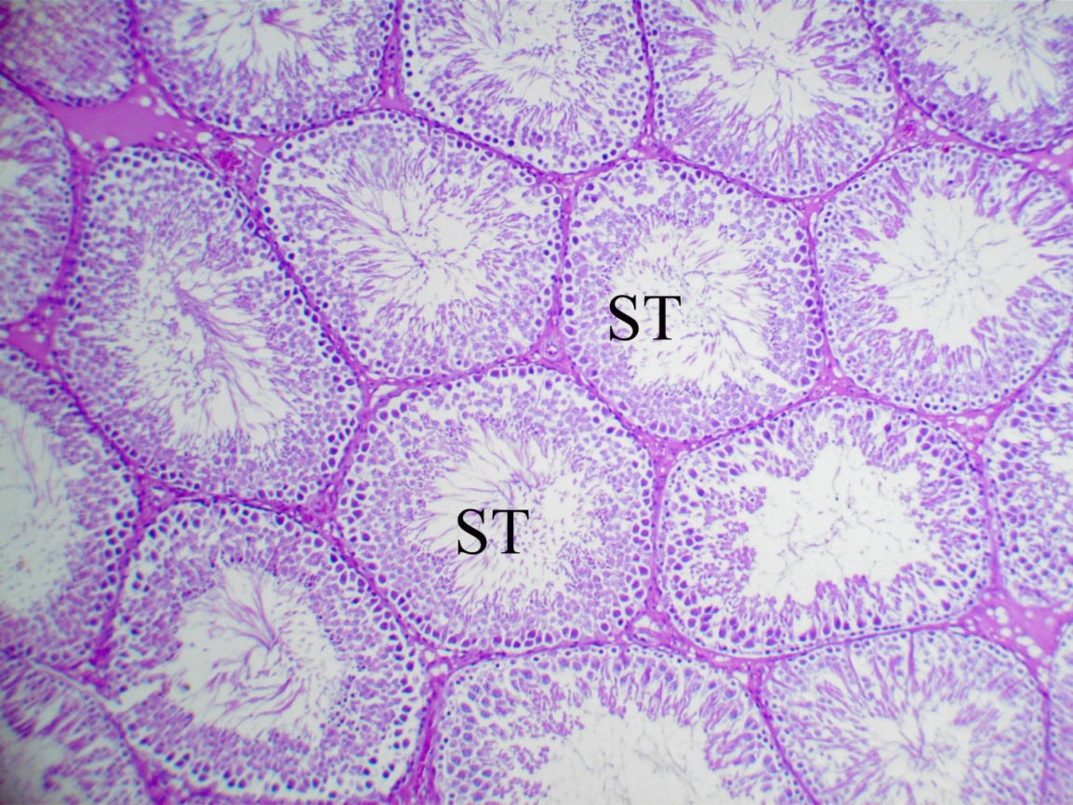 | 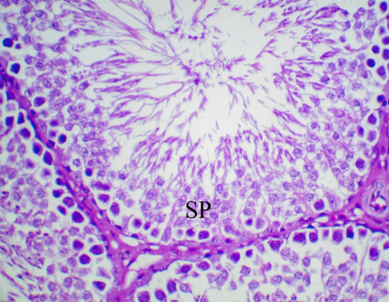 | 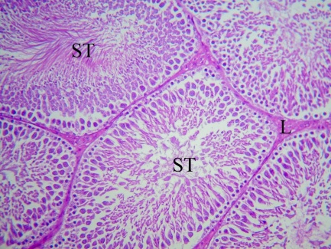
F | E | D
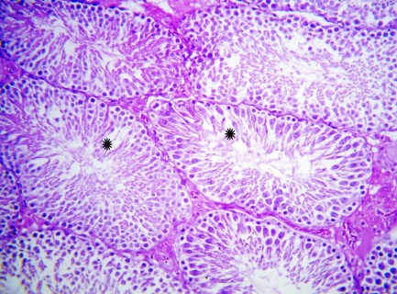 | 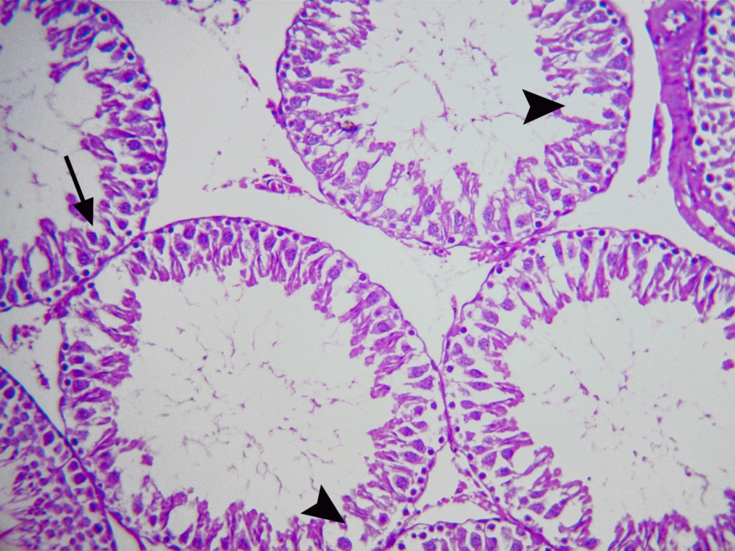 | 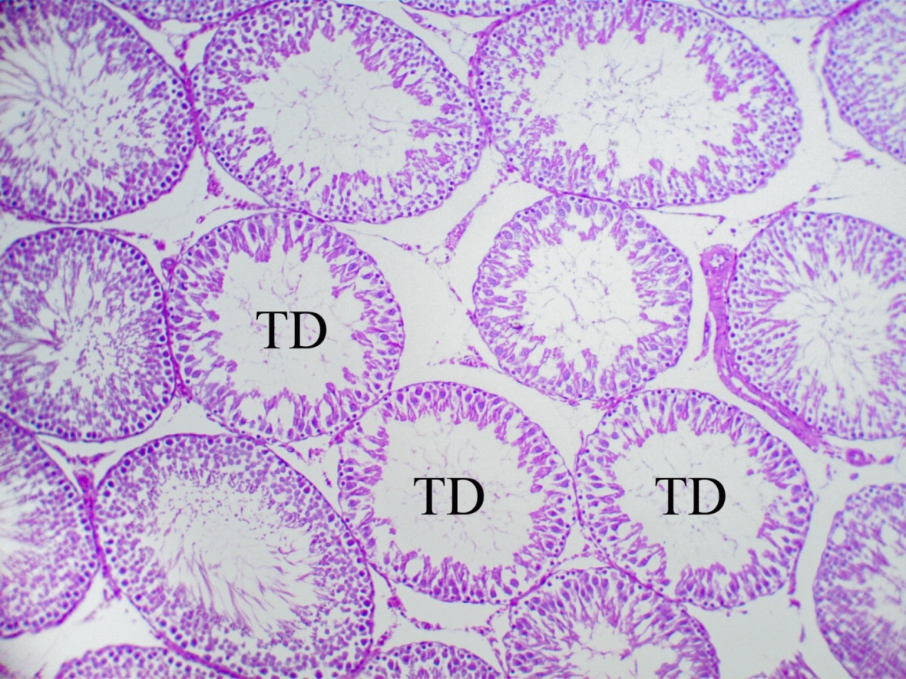
I | H | G
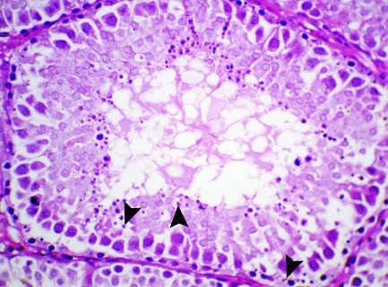 | 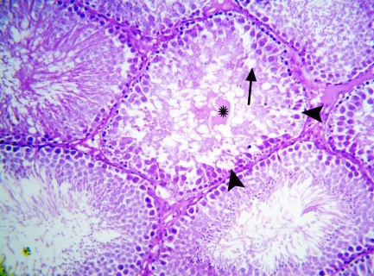 | 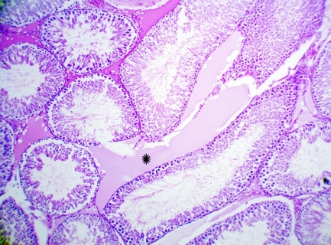
Fig.1. A: Testis of control rat showing normal spermatogenesis with well-organized seminiferous tubules (ST) and Leydig cells (L). H&E stain x 200. B: Testis of rat treated with Terfezia claveryi (50 mg/kg) showing intact germinal epithelium, with active spermatogenic cells (SP) at various stages of development. H&E stain x 400. C: Testis of rat treated with Terfezia claveryi (50 mg/kg) showing normal spermatogenesis with well-organized seminiferous tubules (ST). H&E stain x 100. D: Testis of Lead-Treated rat showing marked testicular degeneration (TD) of the seminiferous tubules. H&E stain x 100. E: Testis of Lead-Treated rat showing degenerated tubules with micro- and macro-vacuolation of germinal epithelium (arrow) and Sertoli cells (arrowhead). H&E stain x 200. F: Testis of rat treated with lead + 50 mg Terfezia claveryi showing moderate testicular degeneration (asterisk). H&E stain x 200. G: Testis of rat treated with lead + 50 mg Terfezia claveryi showing moderate interstitial edema (asterisk) separates the seminiferous tubules. H&E stain x 100. H: Testis of rat treated with lead + 50 mg Terfezia claveryi showing degenerated tubules with micro- and macro-vacuolation of germinal epithelium (arrow) and Sertoli cells (arrowhead), with reduced spermatogenesis (asterisk). H&E stain x 200. I: Testis of rat treated with lead + 50 mg Terfezia claveryi showing apoptosis (arrowhead) of some spermatocytes or spermatids characterized by condensed nuclei and apoptotic bodies. H&E stain x 400.

Testis of rats treated with the methanolic extract of Terfezia claveryi (200 mg/kg) and / lead acetate
C | B | A
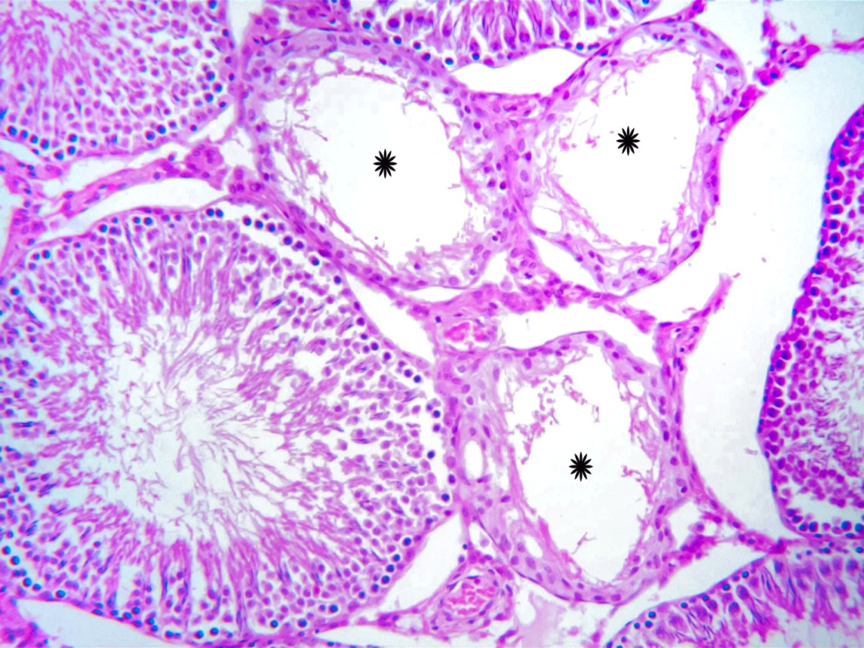 | 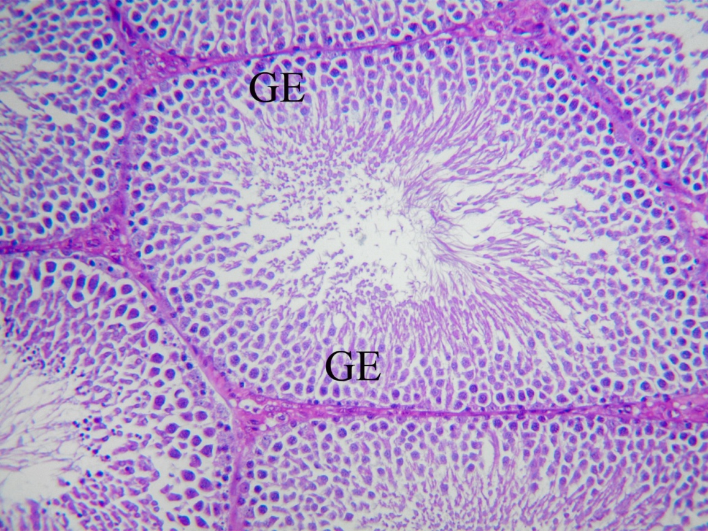
F | E | D
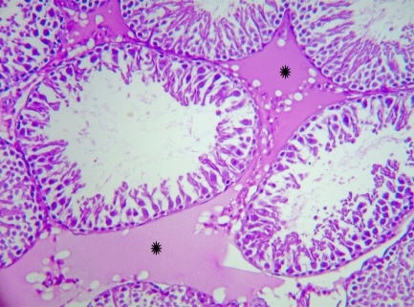 | 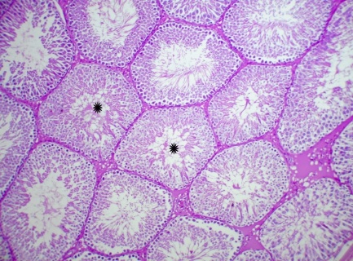 | 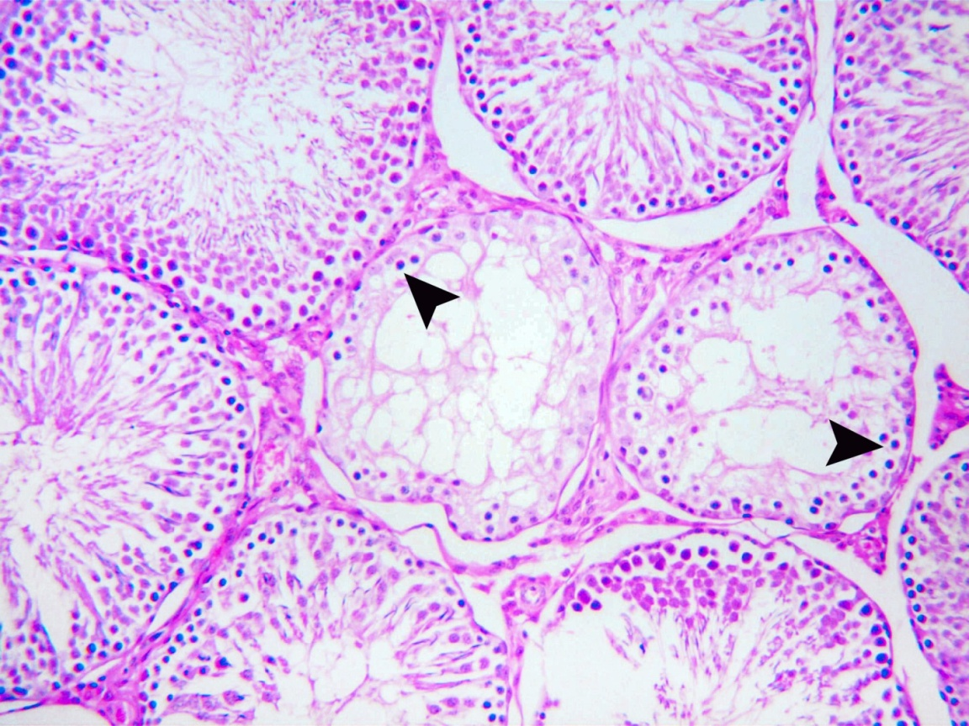

Fig.2. A: Testis of control rat showing normal spermatogenesis with well-organized seminiferous tubules (ST) and Leydig cells (L). H&E stain x 200. B.: Testis of rat treated with 200 mg Terfezia claveryi showing active spermatogenesis, with well-organized germinal epithelium (GE). H&E stain x 200. C: Testis of Lead-Treated rat showing severe atrophy of seminiferous tubules (asterisk)., with irregular, undulant basement membranes. H&E stain x 200. D: Testis of Lead-Treated rat showing atrophied seminiferous tubules with germ cells depletion, and lined by one or two layers of vacuolated cells (arrowhead). H&E stain x 200. E: Testis of rat treated with lead + 200 mg Terfezia claveryi showing maintained normal architecture in the majority of the testicular tissue with mild testicular degeneration (TD) of few seminiferous tubules. H&E stain x 100. F: Testis of rat treated with lead + 200 mg Terfezia claveryi showing mild exfoliation of some germ cells (arrowhead) in lumen of the seminiferous tubules. H&E stain x 400.

Tests of rats treated with silymarin (200 mg/kg) and / lead acetate

C | B | A
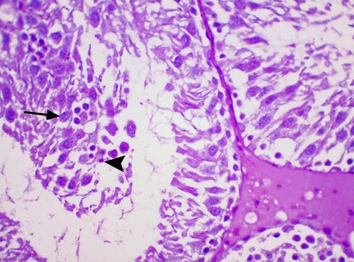 | 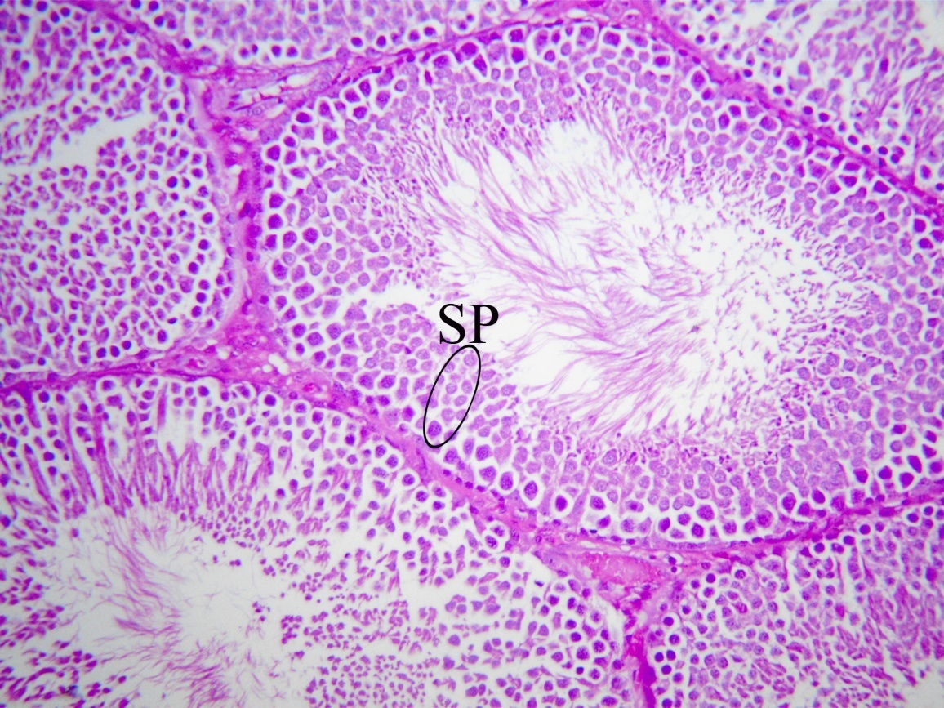
F | E | D
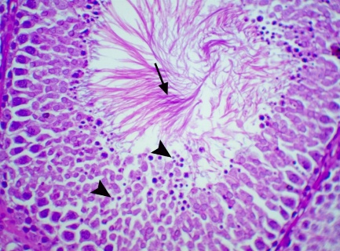 | 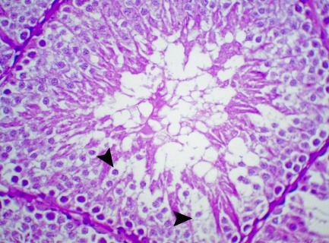 | 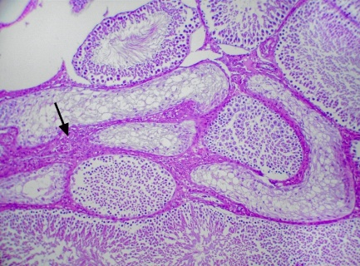

Fig.3. A: Testis of control rat showing normal spermatogenesis with well-organized seminiferous tubules (ST) and Leydig cells (L). H&E stain x 200. B. Testis of Silymarin-Treated rat showing active and normal spermatogenesis (SP). H&E stain x 200. C: Testis of Lead-Treated rat showing apoptotic bodies (arrowhead) mixed with cellular debris and sloughed germ cells (arrow) in the lumen of degenerated tubules. H&E stain x 400. D: Testis of Lead-Treated rat showing marked increase in the interstitial tissue (arrow) separates the degenerated tubules. H&E stain x 100. E: Testis of rat treated with lead + Silymarin showing degenerated tubules with micro- and macro-vacuolation (arrowhead) of germinal epithelium and Sertoli cells. H&E stain x 400. F: Testis of rat treated with lead + Silymarin showing apoptosis (arrowhead) of some germ cells; however, note also large numbers of mature spermatids (arrow). H&E stain x 400.

Prostate gland:

Prostate gland of rats treated with the methanolic extract of Terfezia claveryi (50 mg/kg) and / lead acetate

B | A
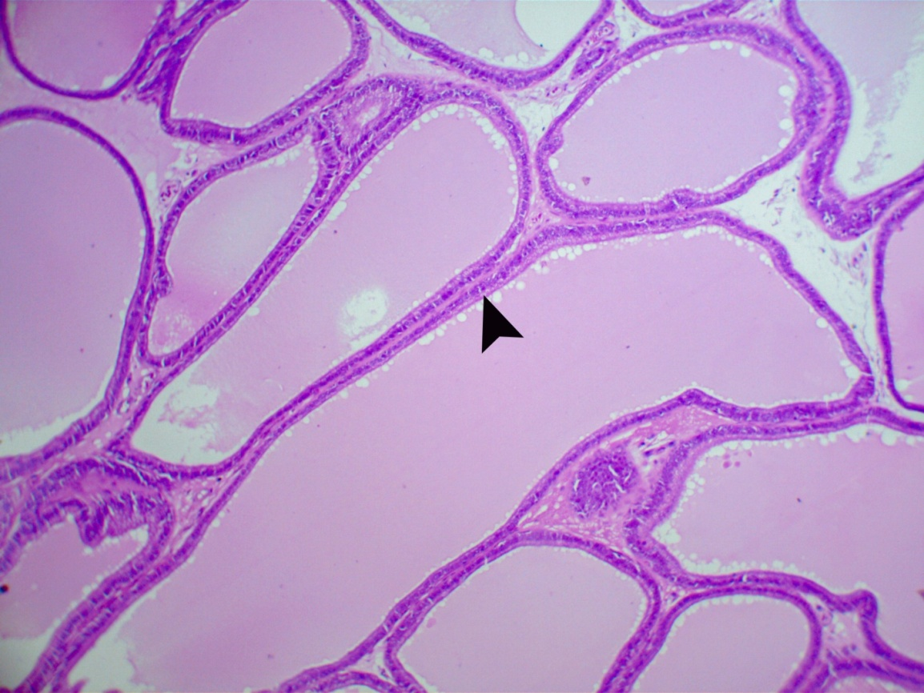 | 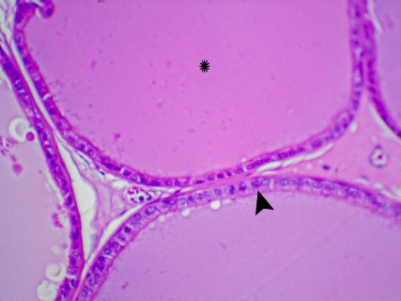
D | C
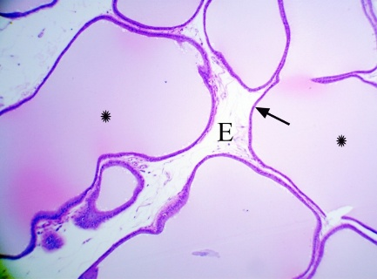 | 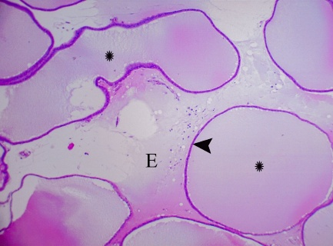

Fig.4. A: Prostate gland of control rat showing normal acinar structures with a uniform epithelial lining (arrowhead) and secretory material (asterisk) in glandular lumen. H&E stain x 400. B: Prostate gland of rat treated with Terfezia claveryi (50 mg/kg) showing well-maintained acinar structures with a uniform epithelial lining (arrowhead). H&E stain x 100. C: Prostate gland of Lead-Treated rat showing marked interstitial edema (E) and ectatic acini (asterisk) lined by attenuated epithelium (arrowhead). H&E stain x 100. D: Prostate gland of rat treated with lead + 50 mg Terfezia claveryi showing ectatic acini (asterisk) lined by attenuated epithelium (arrow) with moderate interstitial edema (E). H&E stain x 200.

Prostate gland of rats treated with the methanolic extract of Terfezia claveryi (200 mg/kg) and / lead acetate

B | A
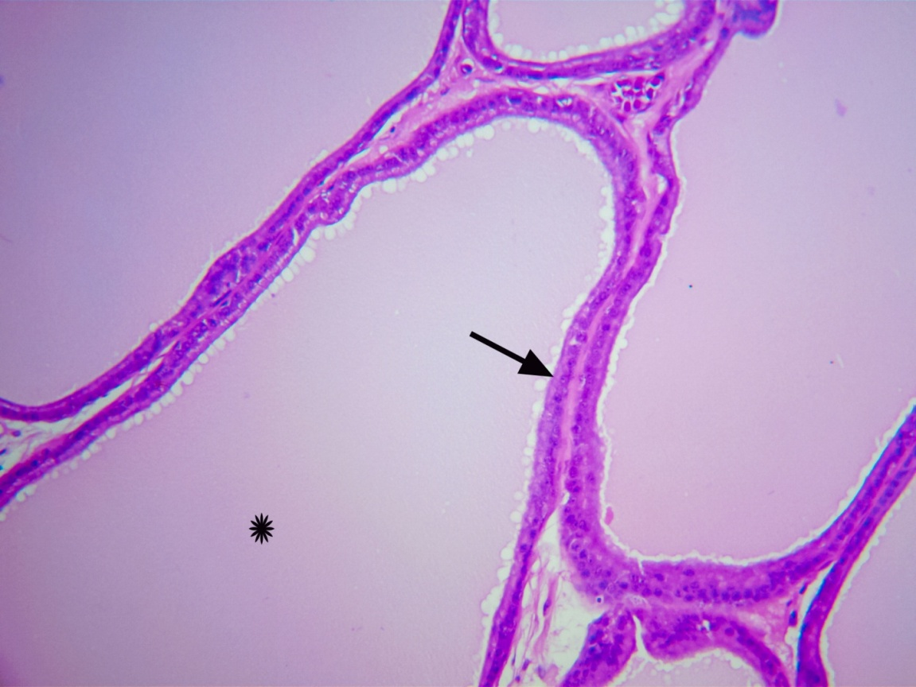
D | C
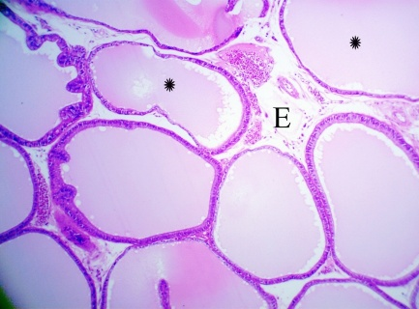

Fig. 5. A: Prostate gland of control rat showing normal acinar structures with a uniform epithelial lining (arrowhead) and secretory material (asterisk) in glandular lumen. H&E stain x 400. B: prostate gland Terfezia claveryi (200 mg) showing well-maintained acinar structures with normal epithelial integrity (arrow) and secretory activity (asterisk). H&E stain x 200. C: Prostate gland of Lead-Treated rat showing marked interstitial edema (E) and ectatic acini (asterisk) lined by attenuated epithelium (arrowhead). H&E stain x 100. D: Prostate gland of rat treated with lead + 200 mg Terfezia claveryi showing mild ectatic acini (asterisk) and interstitial edema (E). H&E stain x 200.

Prostate gland of rats treated with silymarin (200 mg/kg) and / lead acetate
B | A
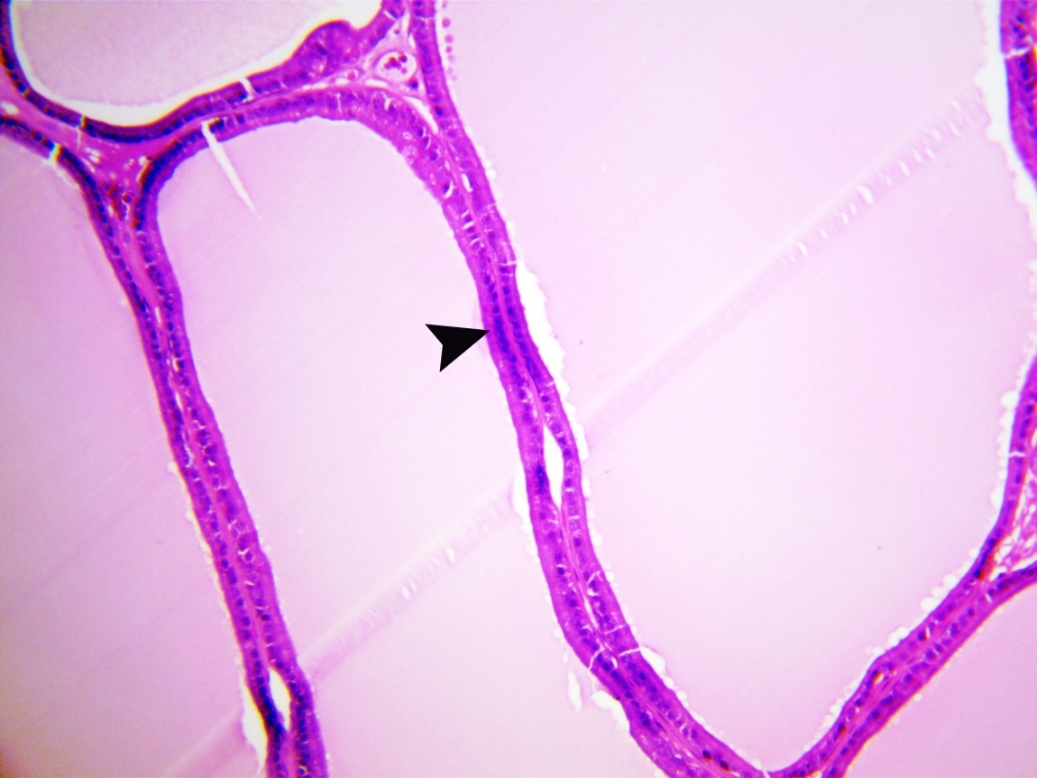
D | C
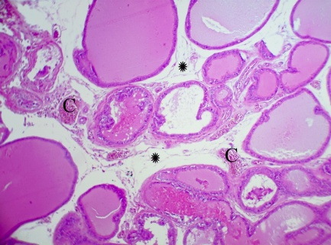

Fig. 6. A: Prostate gland of control rat showing normal acinar structures with a uniform epithelial lining (arrowhead) and secretory material (asterisk) in glandular lumen. H&E stain x 400. B: Prostate gland of Silymarin-Treated rat showing normal acinar structures with a uniform epithelial lining (arrowhead). H&E stain x 200. C: Prostate gland of Lead-Treated rat showing marked interstitial edema (E) and ectatic acini (asterisk) lined by attenuated epithelium (arrowhead). H&E stain x 100. D: Prostate gland of rat treated with lead + Silymarin showing moderate interstitial edema (asterisk) and congestion (C). H&E stain x 100.

Seminal vesicle:

Seminal vesicle of rats treated with the methanolic extract of Terfezia claveryi (50 mg/kg) and / lead acetate

B | A
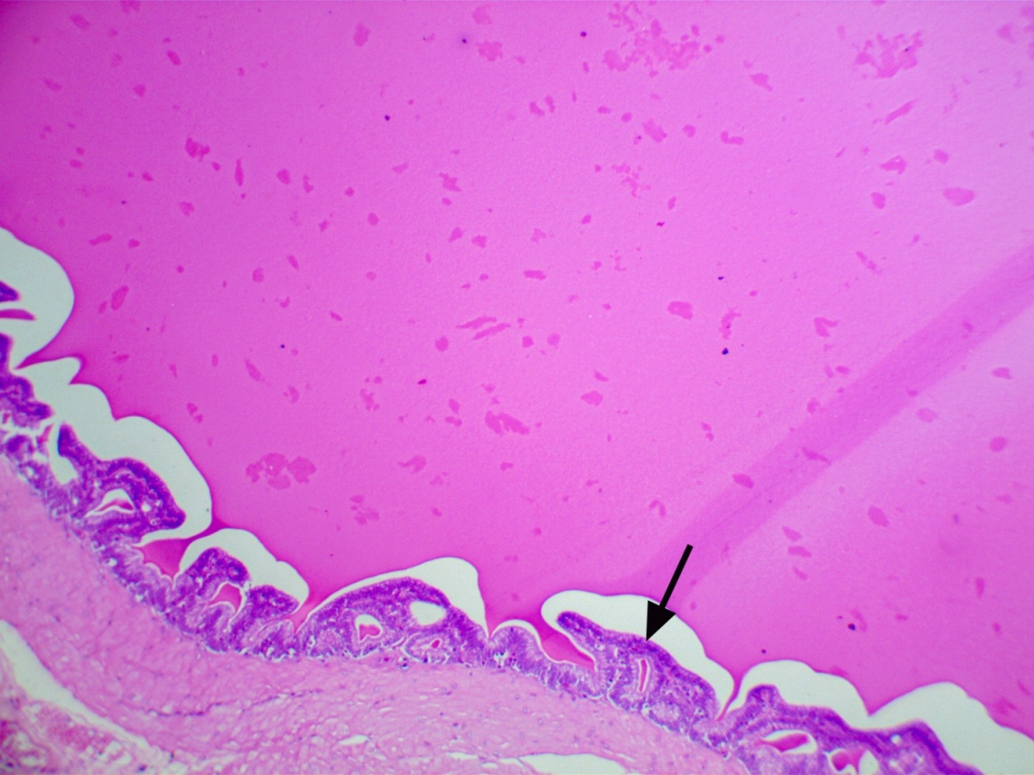 | 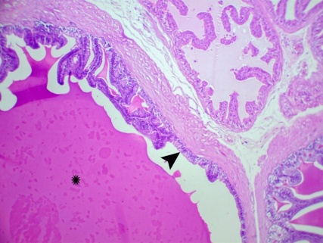
D | C
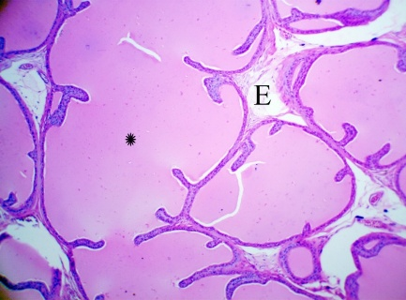 | 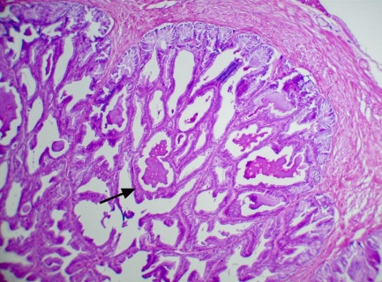

Fig.7. A: Seminal vesicle of control rat showing intact glandular epithelium (arrowhead) with well-developed secretory activity (asterisk). H&E stain x 200. B: Seminal vesicle of rat treated with Terfezia claveryi (50 mg/kg) showing normal histological architecture with a well-preserved glandular epithelium (arrow). H&E stain x 100. C: Seminal vesicle of Lead-Treated rat showing marked epithelial hyperplasia characterized by papillary proliferations (arrow) into the lumen. H&E stain x 100. D: Seminal vesicle of rat treated with lead + 50 mg Terfezia claveryi showing dilated glands (asterisk) with mild interstitial edema (E). H&E stain x 200.

Seminal vesicle of rats treated with the methanolic extract of Terfezia claveryi (200 mg/kg) and / lead acetate
B | A
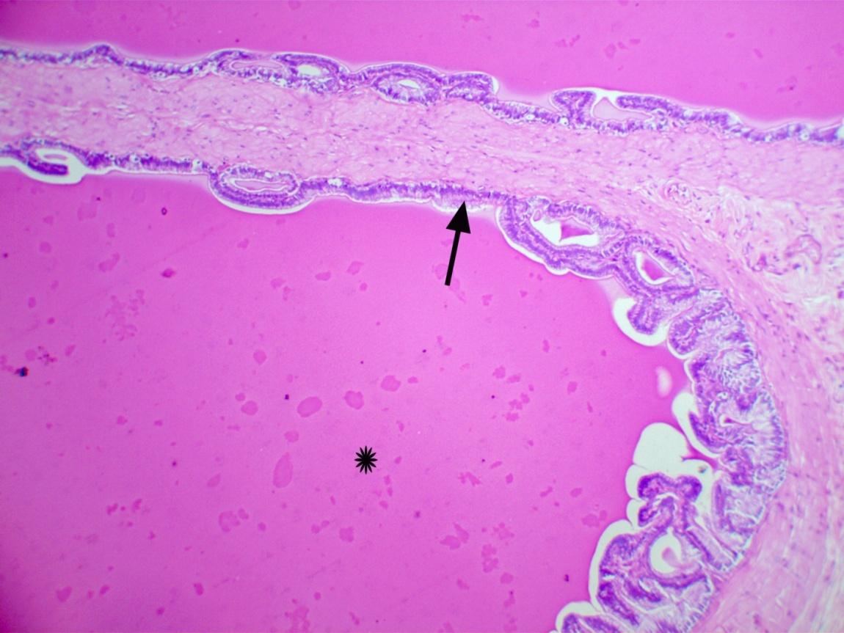
E | D
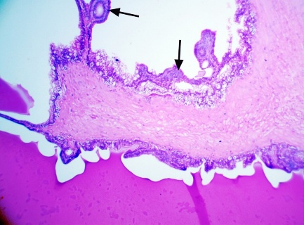 | 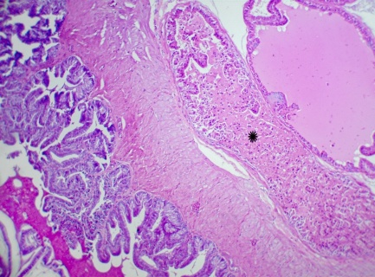
Fig.8. A: Seminal vesicle of control rat showing intact glandular epithelium (arrowhead) with well-developed secretory activity (asterisk). H&E stain x 200. B: Seminal vesicle of rat treated with 200 mg Terfezia claveryi showing normal epithelial integrity (arrow) and secretory activity (asterisk). H&E stain x 100. C: Seminal vesicle of Lead-Treated rat showing necrotic debris (asterisk) in the lumen of the gland. H&E stain x 100. D: Seminal vesicle of rat treated with lead + 200 mg Terfezia claveryi showing mild epithelial hyperplasia (arrow). H&E stain x 200.

.

Seminal vesicle of rats treated with silymarin (200 mg/kg) and / lead acetate
B | A
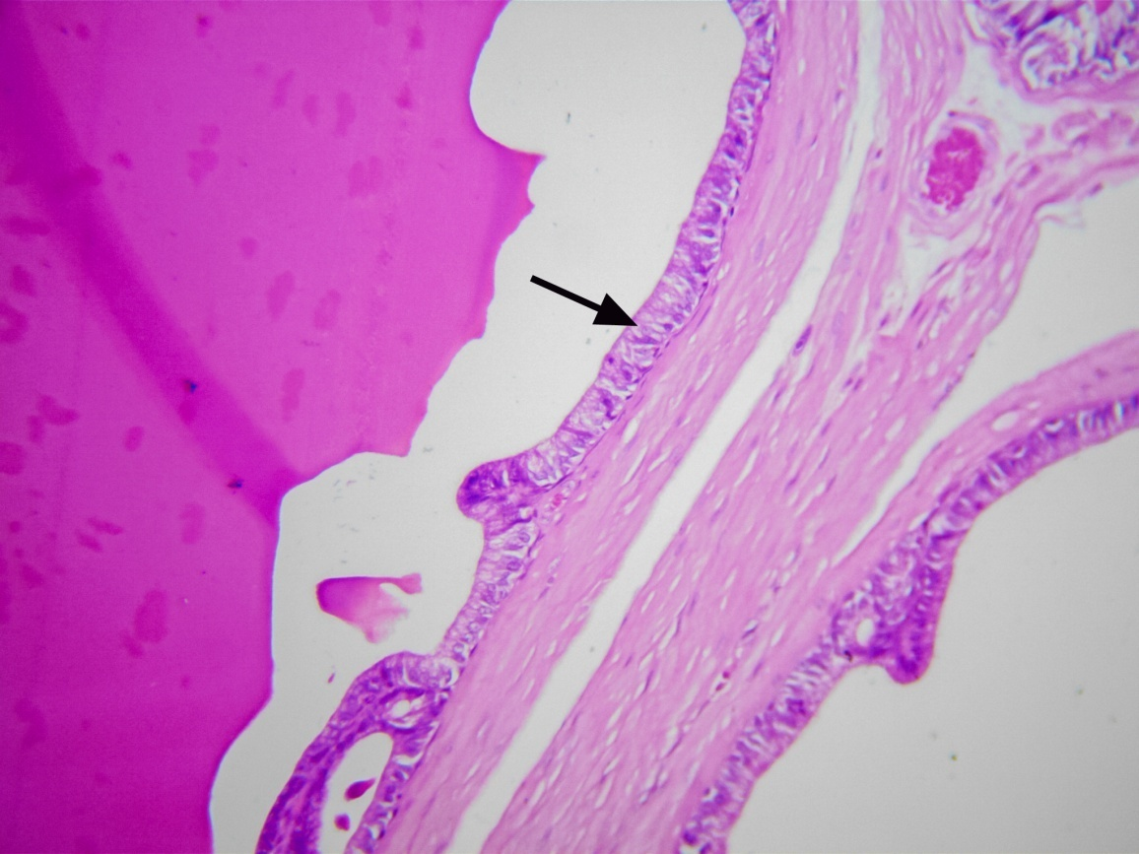
D | C
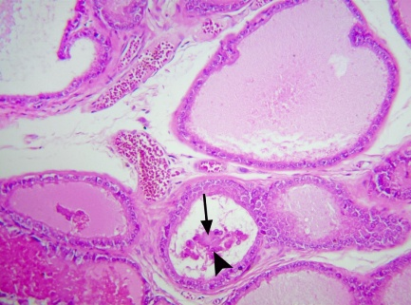 | 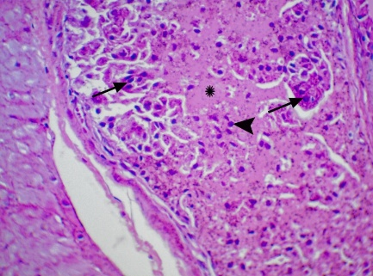
Fig. 9. A: Seminal vesicle of control rat showing intact glandular epithelium (arrowhead) with well-developed secretory activity (asterisk). H&E stain x 200. B: Seminal vesicle of Silymarin-Treated rat showing normal histological architecture with a well-preserved glandular epithelium (arrow). H&E stain x 400. C: Seminal vesicle of Lead-Treated rat showing necrotic debris (asterisk) mixed with exfoliated epithelium (arrow) and inflammatory cells (arrowhead) in the lumen of the gland. H&E stain x 400. D: Seminal vesicle of rat treated with lead + Silymarin showing necrotic debris (arrow) and exfoliated epithelium (arrowhead) in the glandular lumen. H&E stain x 200.

Scoring of Histopathological Lesions in the Testis:

Scoring of Histopathological lesions in the Testis
The following semi-quantitative scoring system is applied severity of the
Testicular Degeneration
0 = Normal, intact seminiferous tubules with full spermatogenesis.
1 = Mild degeneration; slight disorganization of germ cells.
2 = Moderate degeneration; some loss of spermatogenic layers.
3 = Severe degeneration; germ cell depletion with only Sertoli cells or a few spermatogonia.
Sertoli Cell Damage
0 = Normal structure.
1 = Mild disorganization of Sertoli cells.
2 = Vacuolization of Sertoli cells.
3 = Severe damage or complete absence.
Germinal Epithelium Apoptosis & Exfoliation
0 = No apoptosis/necrosis.
1 = Mild apoptotic cell presence.
2 = Moderate apoptosis.
3 = Severe necrosis with tissue disintegration.
Spermatogenesis Arrest
0 = Full spermatogenesis present.
1 = Mild reduction, few elongated spermatids missing.
2 = Moderate arrest at spermatocyte or round spermatid stage.
3 = Severe arrest, with only spermatogonia or Sertoli cells remaining
Interstitial Tissue Changes
0 = Normal size and distribution.
1 = Mild thickening without hyperplasia.
2 = Moderate thickening with hyperplasia of Leydig cells.
3 = Severe thickening with hyperplasia of Leydig cells and tubular atrophy.
Interstitial Edema
0 = Normal interstitial space.
1 = Mild edema.
2 = Moderate edema with mild inflammatory infiltration.
3 = Severe edema with increased inflammatory cells.

Morphometric analysis
Morphometric analysis is conducted by measuring the diameter and epithelial thickness of semineferous tubules of each experimental group using the ImageJ program.
Only Random distributed round or nearly round tubules are selected be measured (to avoid oblique sections).
30 seminiferous tubules per animal are measured for statistical accuracy.
At least 5 animals per group, with 150 tubules per group total.

Table 13 Comparative Scoring of testicular Histopathological Changes in experimental rat groups (N=5)
 |  | Test. Deg |  |  |  |  | Sertoli Damage |  |  |  |  | Germ. Epith Apopt & Exf |  |  |  |  | Spermatogen esis Arrest |  |  |  |  | Interstitial Tis. Changes |  |  |  |  | Interstitial Edema
 |  | 1 | 2 | 3 | 4 | 5 | 1 | 2 | 3 | 4 | 5 | 1 | 2 | 3 | 4 | 5 | 1 | 2 | 3 | 4 | 5 | 1 | 2 | 3 | 4 | 5 | 1 | 2 | 3 | 4 | 5
Control | G1 | 0 | 0 | 0 | 0 | 0 | 0 | 0 | 0 | 0 | 0 | 0 | 0 | 0 | 0 | 0 | 0 | 0 | 0 | 0 | 0 | 0 | 0 | 0 | 0 | 0 | 0 | 0 | 0 | 0 | 0
50 mg | G2 | 0 | 0 | 0 | 0 | 0 | 0 | 0 | 0 | 0 | 0 | 0 | 0 | 0 | 0 | 1 | 0 | 1 | 0 | 0 | 0 | 0 | 0 | 0 | 0 | 0 | 0 | 0 | 0 | 0 | 0
200 mg | G3 | 0 | 0 | 1 | 0 | 0 | 0 | 0 | 0 | 0 | 0 | 0 | 0 | 0 | 1 | 0 | 0 | 0 | 1 | 0 | 1 | 0 | 0 | 0 | 0 | 0 | 0 | 0 | 0 | 0 | 0
Silymarin | G4 | 0 | 0 | 1 | 0 | 0 | 0 | 0 | 0 | 0 | 0 | 0 | 0 | 0 | 0 | 0 | 0 | 0 | 1 | 0 | 0 | 0 | 0 | 0 | 0 | 0 | 0 | 0 | 0 | 0 | 0
Lead | G5 | 2 | 3 | 3 | 2 | 2 | 2 | 2 | 2 | 3 | 3 | 2 | 2 | 3 | 2 | 3 | 2 | 3 | 1 | 2 | 2 | 2 | 3 | 2 | 1 | 1 | 3 | 3 | 2 | 2 | 3
Lead+ 50 mg | G6 | 1 | 2 | 1 | 2 | 1 | 1 | 1 | 1 | 0 | 1 | 2 | 2 | 1 | 1 | 1 | 2 | 1 | 2 | 1 | 2 | 0 | 1 | 1 | 0 | 0 | 2 | 2 | 1 | 2 | 1
Lead+ 200 mg | G7 | 0 | 0 | 1 | 1 | 1 | 0 | 1 | 0 | 1 | 0 | 0 | 1 | 1 | 0 | 1 | 0 | 1 | 1 | 1 | 0 | 0 | 1 | 0 | 0 | 0 | 1 | 1 | 1 | 0 | 0
Lead + Silymarin | G8 | 1 | 1 | 1 | 2 | 1 | 1 | 1 | 2 | 0 | 1 | 1 | 1 | 1 | 1 | 0 | 1 | 1 | 1 | 0 | 1 | 0 | 0 | 0 | 0 | 0 | 1 | 1 | 2 | 1 | 0

Summary of Statistical Analysis: Testicular Histology Across Experimental Groups
This study evaluated testicular tissue across eight groups (G1–G8) using six pathological parameters, each scored from 0 (normal) to 5 (severe damage).
Key Observations:
Control Groups (G1–G4): G1 showed normal histology (scores = 0). G2–G4 had minimal changes (scores ≤1).
Experimental Groups (G5–G8): G5 showed the most severe damage (scores 2–3). G6–G8 had moderate damage levels.

Table 14: Effect of T. claveryi, lead and their coadministration on Scoring of Histopathological lesions in the Testes:
(Parameter) | Control | 50mg | 200mg | Silymarin | Lead | Lead+50mg | Lead+200mg | Lead + Silymarin)
 | Group 1 | Group 2 | Group 3 | Group 4 | Group 5 | Group 6 | Group 7 | Group 8
Testicular Degeneration | 0.0 ± 0.0 (A) | 0.0 ± 0.0 (A) | 0.2 ± 0.4 (A) | 0.2 ± 0.4 (A) | 2.2 ± 0.4 (B) | 1.4 ± 0.5 (C) | 0.4 ± 0.5 (A) | 1.0 ± 0.0 (C)
Sertoli Cell Damage | 0.0 ± 0.0 (A) | 0.0 ± 0.0 (A) | 0.0 ± 0.0 (A) | 0.0 ± 0.0 (A) | 2.4 ± 0.5 (B) | 1.0 ± 0.0 (C) | 0.2 ± 0.4 (A) | 1.2 ± 0.4 (C)
Germ Cell Apoptosis | 0.0 ± 0.0 (A) | 0.2 ± 0.4 (A) | 0.2 ± 0.4 (A) | 0.0 ± 0.0 (A) | 2.6 ± 0.5 (B) | 1.6 ± 0.5 (C) | 0.4 ± 0.5 (A) | 1.0 ± 0.0 (C)
Spermatogenesis Arrest | 0.0 ± 0.0 (A) | 0.2 ± 0.4 (A) | 0.4 ± 0.5 (A) | 0.2 ± 0.4 (A) | 2.2 ± 0.4 (B) | 1.6 ± 0.5 (C) | 0.4 ± 0.5 (A) | 1.0 ± 0.0 (C)
Interstitial Changes | 0.0 ± 0.0 (A) | 0.0 ± 0.0 (A) | 0.0 ± 0.0 (A) | 0.0 ± 0.0 (A) | 2.0 ± 0.7 (B) | 0.2 ± 0.4 (A) | 0.0 ± 0.0 (A) | 0.0 ± 0.0 (A)
Interstitial Edema | 0.0 ± 0.0 (A) | 0.0 ± 0.0 (A) | 0.0 ± 0.0 (A) | 0.0 ± 0.0 (A) | 2.8 ± 0.4 (B) | 1.6 ± 0.5 (C) | 0.2 ± 0.4 (A) | 1.4 ± 0.5 (C)
Values in the identical row bearing distinct letters are deemed significantly dissimilar at P < 0.05 according to the Tukey post hoc multiple comparison test. The values are presented as the mean ± S.D. (N = 5 rats).

Conclusions:
Damage Severity: G5 > G6 > G8 > G7 > G4 > G3 > G2 > G1.
Most Sensitive Indicators: Spermatogenic arrest and Sertoli cell damage.
Most Resistant: Interstitial changes.
200 mg showed the best protective effect among treated groups.

Descriptive Statistics
Key statistical measures (mean ± standard deviation) for seminiferous tubule diameter (µm):
Table 14: Effect of T. claveryi on Tubule Diameter changes.
Group | Mean ± SD (µm) | P-value (vs control)
Control | 287.5 ± 1.2 A | -
50 mg T. claveryi | 276.8 ± 1.5 C | P < 0.05
200 mg T. claveryi | 281.9 ± 1.3 B | P < 0.05
Silymarin | 286.7 ± 1.4 A | P > 0.05
Lead | 198.3 ± 1.8 F | P < 0.05
50 mg T. claveryi + Lead | 239.1 ± 1.6 E | P < 0.05
200 mg T. claveryi + Lead | 248.9 ± 1.5 D | P < 0.05
Silymarin + Lead | 241.6 ± 1.7 E | P < 0.05
Values in the identical column bearing distinct letters are deemed significantly dissimilar at P < 0.05 according to the Tukey post hoc multiple comparison test. The values are presented as the mean ± S.D. (N = 5 rats).

Histological Analysis of Germinal Epithelium Thickness Following Lead Exposure and Treatment with Terfezia claveryi and Silymarin
Histological examination of germinal epithelial thickness in the seminiferous tubules revealed significant effects of lead (Pb) exposure and treatment with Terfezia claveryi and Silymarin. In the lead-only group (G5), there was a severe thinning of the germinal epithelium, with a mean thickness of 51.91 ± 8.32 µm, representing approximately a 42% reduction compared to the control group (G1: 89.23 ± 5.87 µm), indicating germinal epithelial atrophy due to Pb toxicity. This difference was statistically significant (p < 0.001).
In the groups treated with Terfezia claveryi (G6, G7), there was restoration of epithelial thickness. The group receiving 200 mg/kg of T. claveryi (G7) showed the best recovery with a mean thickness of 76.33 ± 6.56 µm, approaching near-normal values. This recovery was statistically significant when compared to the Pb-only group (G5) (p < 0.001). For the Silymarin-treated group (G8), the germinal epithelium was preserved with a thickness of 88.00 ± 6.00 µm, reflecting a near-normal morphology, but there was no significant difference compared to the control group (G1). This suggests that Silymarin maintained epithelial integrity but was less effective than T. claveryi at higher doses in promoting recovery from Pb toxicity.
The Lead + Silymarin group (G8) showed moderate recovery with a mean thickness of 75.00 ± 7.00 µm, but this was still statistically less significant than the recovery observed in the 200 mg/kg T. claveryi group (G7) (p = 0.018), further emphasizing the superior protective effect of T. claveryi.
Table 15: Effect of T. claveryi on Germinal Epithelium Thickness (µm)
Groups |  | Mean ± SD (µm) | P-value
G1 | Control | 89.42 ± 4.82 A | -
G2 | 50 mg | 88.85 ± 6.05 A | P > 0.05
G3 | 200 mg | 88.36 ± 4.60 A | P > 0.05
G4 | Silymarin | 88.70 ± 6.13 A | P > 0.05
G5 | Lead | 52.74 ± 6.79 D | P < 0.05
G6 | 50 mg + Lead | 70.38 ± 6.20 C | P < 0.05
G7 | 200 mg + Lead | 79.87 ± 4.79 B | P < 0.05
G8 | Silymarin + Lead | 76.73 ± 4.85 C | P < 0.05
Values in the identical column bearing distinct letters are deemed significantly dissimilar at P < 0.05 according to the Tukey post hoc multiple comparison test. The values are presented as the mean ± S.E. (N = 5 rats).

Statistical Results:
G5 (Lead) vs. G1 (Control): p < 0.001, confirming the severe Pb-induced damage (statistically significant). G7 (Pb + 200 mg/kg T. claveryi) vs. G5: p < 0.001, showing significant protection by T. claveryi (statistically significant). G7 vs. G8 (Lead + Silymarin): p = 0.018, indicating that T. claveryi outperformed silymarin (statistically significant). These findings confirm that T. claveryi impose superior protection against Pb-induced epithelial damage, particularly at the higher dose, compared to silymarin.

Discussion:
The current investigation provides strong evidence of the deleterious effects of lead (Pb) exposure on male reproductive health, particularly testicular structure and function, while highlighting the significant protective potential of Terfezia claveryi (T. claveryi) extract. Across all measured parameters—including histomorphometry, hormonal status, oxidative stress markers, sperm characteristics, organ indices, and body weight—lead exerted profound toxic effects. These adverse outcomes were largely mitigated by T. claveryi treatment, especially at a high dose (200 mg/kg), which frequently outperformed silymarin, a well-known phytochemical antioxidant.

Histomorphometric and Histological Findings
One of the most striking findings was the marked reduction in germinal epithelium thickness and seminiferous tubule diameter in the lead-only group (G5), with respective means of 51.91 ± 8.32 µm and 197.91 ± 15.32 µm. These declines, relative to the control (G1), reflect significant epithelial atrophy and testicular degeneration, confirming that Pb exposure disrupts normal spermatogenesis (Flora et al., 2012). In contrast, treatment with T. claveryi extract—particularly at 200 mg/kg (G7)—restored both parameters near to control levels (79.87 ± 4.79 µm and 248.9 ± 1.5 µm, respectively), indicating notable protection.
Histopathological scoring further supported this outcome, where G5 (Pb-only) had the highest cumulative scores for testicular degeneration, Sertoli cell damage, germ cell apoptosis, and interstitial changes, while G7 showed remarkable reductions in these lesions. The histo-protective effects of T. claveryi may stem from its antioxidant and membrane-stabilizing properties, which preserve testicular microarchitecture and reduce germ cell loss (Zhang et al., 2018; Li et al., 2020).

Endocrine Disruption and Hormonal Recovery
Pb exposure drastically reduced testosterone levels by approximately 71% compared to control (0.56 ± 0.04 ng/mL in G5 vs. 1.95 ± 0.06 in G1). This likely results from oxidative damage to Leydig cells, key testosterone-producing cells in the testes (Gorell et al., 2010). However, high-dose T. claveryi (G7) restored testosterone levels to 1.76 ± 0.05 ng/mL, a non-significant difference compared to the control, and significantly better than the Pb-only group. This suggests that T. claveryi can counteract Pb-induced endocrine disruption, possibly through upregulating steroidogenic enzymes and protecting testicular tissue from ROS-mediated damage (Sermet-Gaudelus et al., 2013).
This study confirm that lead severely disrupts spermatogenesis, most likely through oxidative stress, hormonal imbalance, and direct testicular damage. The protective effects observed with the plant extract, particularly at the 200 mg dose, suggest multiple possible mechanisms of action, including:
1-Effective sperm count restoration at 200 mg
2-Greater efficacy than Silymarin under similar conditions
Together, these findings support the potential use of Terfezia claveryi as a natural therapeutic agent for mitigating heavy metal-induced reproductive toxicity (Table 8).
Biologically, these results demonstrate that lead exerts anti-androgenic effects by damaging Leydig cells and disrupting steroidogenic pathways. In contrast, Terfezia claveryi extract displays dose-dependent androgenic activity, enhancing testosterone synthesis and mitigating oxidative and toxic insults in testicular tissue

Oxidative Stress and Antioxidant Capacity
Lead is well known to provoke oxidative stress, and this was confirmed by a 301% increase in malondialdehyde (MDA) levels in G5, along with reductions in total antioxidant capacity (TAC) and catalase (CAT) activity. These findings are consistent with previous studies reporting increased lipid peroxidation and impaired antioxidant defenses under Pb exposure (Flora et al., 2012).
Treatment with T. claveryi at both 50 mg/kg and 200 mg/kg significantly decreased MDA levels (by 15% and 28.5%, respectively) and improved both TAC and CAT activities. The high-dose extract restored TAC to control and significantly enhanced CAT levels by 24.5% in Pb-exposed animals. These improvements support the antioxidant richness of desert truffles, which are known to contain polyphenols, flavonoids, and polysaccharides (Kalač, 2013). Interestingly, silymarin also showed antioxidant activity but was consistently less effective than T. claveryi in restoring these parameters.
In the context of Terfezia claveryi, this truffle is recognized for its potential antioxidant properties, which may counteract the oxidative stress induced by lead. Antioxidants play a crucial role in mitigating oxidative damage to sperm cells, thereby preserving sperm quality and function. Although direct studies linking Terfezia claveryi with lead-induced reproductive toxicity are scarce, the general principle that dietary antioxidants can ameliorate oxidative stress suggests that consumption of such natural products may provide protective effects against lead toxicity.
In a study evaluating the ameliorative effects of camel milk on lead-induced reproductive toxicity, researchers found that camel milk significantly reduced oxidative stress markers and improved fertility parame ters in male rats exposed to lead acetate (Abdel‐Mobdy, 2024). This suggests that dietary antioxidants may play a crucial role in mitigating the harmful effects of lead on reproductive health. Similarly, another study demonstrated that the administration of Annona squamosa fruit extract improved testicular architecture and function in lead-exposed male rats by modulating oxidative stress pathways (Mobasher, 2024). These findings underscore the potential of natural antioxidants in protecting against lead-induced reproductive toxicity.
Moreover, the interplay between lead exposure and dietary antioxidants is underscored by research indicating that lead can induce testicular damage through oxidative mechanisms, which can be mitigated by antioxidant interventions. For instance, studies have demonstrated that compounds like thymoquinone can ameliorate lead-induced reproductive toxicity in male Wistar rats, suggesting that similar antioxidant-rich foods, including Terfezia claveryi, could have beneficial effects (Adedokun et al., 2023). This highlights the potential for dietary interventions to enhance reproductive health in environments where lead exposure is a concern.
In a review article by Kefer et al. (2009), the role of antioxidants in the treatment of male infertility was discussed. The review highlighted the impact of oxidative stress on sperm quality and the potential therapeutic benefits of antioxidant supplementation in improving male fertility.
The mechanism behind this protective effect may involve improved nutrient utilization, mitigation of oxidative stress, and preservation of cellular integrity under toxic conditions. While Silymarin exhibited moderate protection, its effects were consistently lower than those seen with the higher dose of Terfezia claveryi
The data confirm that lead significantly impairs antioxidant systems through the depletion of TAC. However, the plant extract Terfezia claveryi exhibits strong antioxidant properties, particularly at the 200mg dose, which proved more effective than both the 50mg dose and Silymarin in restoring antioxidant balance.
Lead exposure caused significant oxidative damage, as evidenced by elevated MDA levels. Treatment with Terfezia claveryi markedly reduced this damage, with the 200 mg/kg dose showing the strongest protective effect. The extract likely exerts its action by scavenging free radicals, stabilizing cell membranes, and inhibiting lipid peroxidation. While lower doses and Silymarin offered partial protection, they were less effective compared to the higher dose of Terfezia claveryi.
A clear dose-response relationship was evident, as the 200mg extract outperformed the 50mg extract in both enhancing baseline antioxidant capacity and counteracting lead-induced oxidative stress. This may be attributed to the extract’s potential to scavenge free radicals, preserve enzyme activity.
at a significance level of α = 0.05, 200mg of Terfezia claveryi significantly improves TAC and provides complete protection against lead toxicity. Lower doses offer partial but limited antioxidant support, emphasizing the importance of dose optimization in therapeutic use.

Sperm Quality and Reproductive Organ Indices
Lead exposure significantly impaired sperm count and motility, dropping them to 1.8 × 10⁶/mL and 15%, respectively—just 9% and 27% of control values. Such deficits are typically linked to ROS-induced membrane damage, sperm DNA fragmentation, and mitochondrial dysfunction (Li et al., 2020).
Lead Reduces Testicular Weight Significantly. Animals exposed to lead alone showed a 15.3% drop in testicular weight index (p < 0.01), which reflects clear signs of testicular shrinkage. This is likely due to oxidative stress and hormonal imbalance caused by lead toxicity.
Lead exposure damages the epididymis animals exposed to lead showed a significant 17.3% drop in epididymis weight (p < 0.01), likely due to oxidative stress, disrupted sperm maturation, and hormonal imbalance.
Co-treatment with T. claveryi reversed these impairments. G6 animals had a sperm count of 16.4 × 10⁶/mL and motility of 50%, reflecting partial to near-complete recovery. The 200 mg/kg extract was clearly superior to 50 mg/kg and also outperformed silymarin (which yielded only 12.8 × 10⁶/mL and 45% motility). These benefits may reflect improved mitochondrial function and DNA integrity in spermatozoa, afforded by antioxidant protection.
In terms of accessory reproductive organs, lead caused reductions in the epididymal and testicular weight indices, with the Pb-only group showing a 17.3% and 15.3% decrease, respectively. Once again, high-dose of T. claveryi restored epididymal index completely (0% change vs. control) and significantly improved testicular index to within 6.8% of control values. These parameters further demonstrate the efficacy of T. claveryi in preserving reproductive tissue integrity and function.
Lead exposure has been shown to adversely affect male reproductive parameters. Studies indicate that lead can induce oxidative stress, which is detrimental to sperm quality and overall fertility. Specifically, lead exposure has been associated with increased levels of reactive oxygen species (ROS) in the seminiferous epithelium, leading to cellular apoptosis and disruption of spermatogenesis, which ultimately impairs male fertility. This oxidative stress is estimated to contribute to a decrease in semen quality in a significant percentage of males experiencing subfertility (Lv et al. 2025).

Body Weight and General Health Effects
Chronic Pb exposure also led to systemic toxicity, evidenced by a net weight loss of 19.6 grams in the Pb-only group. This may be due to metabolic derangements, poor appetite, and tissue wasting commonly seen with lead poisoning (ATSDR, 2007). In contrast, T. claveryi-treated groups gained weight during the experiment (especially G7: +26.6 g), suggesting an overall improvement in health status and a reduction in Pb-induced systemic stress.
Lead exposure disrupts catalase activity, but the plant extract shows dose-dependent antioxidant effects, with 200 mg offering the most significant protection against lead-induced oxidative stress, at α = 0.05, the 200 mg plant extract provides substantial protection against lead toxicity by enhancing catalase activity and reducing oxidative stress, suggesting its potential as a therapeutic agent.
Exposure to lead resulted in a sharp and statistically significant elevation in MDA levels—approximately a threefold increase compared to the control group (p < 0.001). This confirms that lead induces strong oxidative stress through lipid peroxidation. All groups exposed to lead exhibited significantly higher MDA values than the untreated control group (p < 0.001), indicating widespread oxidative damage

Comparative Efficacy of T. claveryi vs. Silymarin
While silymarin exhibited moderate protective effects across multiple domains—confirming its antioxidant properties—T. claveryi, particularly at 200 mg/kg, consistently outperformed it. This was evident in sperm metrics, testicular histology, hormone levels, and antioxidant defenses. Desert truffles are rich in phenolic compounds, unsaturated fatty acids, and bioactive peptides, which may provide synergistic antioxidative, anti-inflammatory, and cytoprotective effects (Zhang et al., 2018; Kalač, 2013).

Conclusion:
In summary, the findings demonstrate that Terfezia claveryi extract provides robust protection against lead-induced testicular toxicity, likely through its antioxidant, anti-apoptotic, and steroidogenesis-supportive actions. The high-dose extract (200 mg/kg) was especially effective and surpassed the efficacy of silymarin in nearly all measured parameters. These results hypothesis potential use of T. claveryi as a novel natural therapeutic agent in the prevention or treatment of heavy metal-induced reproductive dysfunctions.
Morphometric analysis (Table 14) demonstrated a significant reduction in seminiferous tubule diameter in the lead-treated group (G5: 198.3 ± 1.8 ± 1.8 µm) compared to the control (G1: 287.5 ± 1.2 µm, p < 0.001), confirming severe testicular damage induced by Pb.
Treatment with Terfezia claveryi alone (G2, G3) showed no statistically significant difference from the control group (p > 0.05), indicating its safety at both doses.
Co-administration of T. claveryi with lead (G6 and G7) resulted in a statistically significant improvement in diameter compared to the lead-only group (p < 0.001). The high-dose group (G7: 248.9 ± 1.5 µm) showed a greater recovery than the low-dose group (G6: 239.1 ± 1.6 µm), and also outperformed the lead + silymarin group (G8: 241.6 ± 1.7 µm; p = 0.012).
Silymarin alone (G4: 286.7 ± 1.4 µm) preserved normal morphology, while G8 showed partial but significant recovery compared to G5 (p < 0.001), though less effective than high-dose T. claveryi.
These results confirm the high-dose is more protective of T. claveryi and support its potential superiority over silymarin in alleviating Pb-induced testicular damage.

References
Abdel‐Mobdy, Y. (2024). Evaluation of the camel milk amelioration, the oxidative stress, fertility and mutagenicity of male albino rats exposed to lead acetate, fipronil, and their mixture. Food Science & Nutrition, 12(3), 1564-1572. https://doi.org/10.1002/fsn3.3663
Abbassi, S., George, S. C., Edwards, D. S., di Primio, R., Horsfield, B., & Volk, H. (2014). Generation characteristics of Mesozoic syn- and post-rift source rocks, Bonaparte Basin, Australia: New insights from compositional kinetic modelling. Marine and Petroleum Geology, 50, 148–165. https://doi.org/10.1016/j.marpetgeo.2013.10.010
Abu-Odeh, A., Shehadeh, M., Suaifan, G., Karameh, N., Rahman, D., & Kandil, Y. (2022). In vitro and in vivo antidiabetic activity, phenolic content and microscopical characterization of Terfezia claveryi. Molecules, 27(15), 4843. https://doi.org/10.3390/molecules27154843
ADEDOKUN, K. I., OLADOKUN, O. O., ABRAHAM, T. F., OSUNTOKUN, O. S., ATERE, T. G. & BAIYEWU, (2023). Ameliorative Potential of Thymoquinone on Male Reproductive Functions in Lead Acetate-Induced Reproductive Toxicity in Male Wistar Rats. https://doi.org/10.26538/tjnpr/v7i6.24
Agarwal, A., Virk, G., Ong, C., & du Plessis, S. S. (2014). Effect of oxidative stress on male reproduction. The World Journal of Men's Health, 32(1), 1-17. https://synapse.koreamed.org/articles/1088727
Agency for Toxic Substances and Disease Registry (ATSDR). (2007). Toxicological profile for lead. U.S. Department of Health and Human Services.
AlAhmed, A., & Khalil, H. E. (2019). Antidiabetic activity of Terfezia claveryi: An in vitro and in vivo study. Biomedical and Pharmacology Journal, 12(1), 603–608. https://doi.org/10.13005/bpj/1680
Ali, F. E. M., Badran, K. S. A., Baraka, M. A., Althagafy, H. S., & Hassanein, E. H. M. (2024). Mechanism and impact of heavy metal-aluminum (Al) toxicity on male reproduction: Therapeutic approaches with some phytochemicals. Life Sciences, *338, 122461. https://doi.org/10.1016/j.lfs.2023.122461
Arenas, F., Morte, A., & Navarro-Ródenas, A. (2022). Design and validation of qpcr-specific primers for quantification of the marketed Terfezia claveryi and terfezia crassiverrucosa in soil. Journal of Fungi, 8(10), 1095. https://doi.org/10.3390/jof8101095
Bataineh, H., Al-Hamood, M., & Elbetieha, A. (1998). Assessment of aggression, sexual behavior and fertility in adult male rat following long-term ingestion of four industrial metals salts. Human & Experimental Toxicology, 17(10), 570-576. https://doi.org/10.1177/096032719801701008
Bello, N. B., Rabiu, A. M., & Odeh, S. O. (2013). The effect of aqueous leave extract of Nicotiana Tabacum (Tobacco) on some reproductive parameters and micro-anatomical architecture of the testis in male albino wistar rats. Natural Science Research, 5, 137-143. https://2u.pw/be7DBcI

Bhardwaj, J., Paliwal, A., & Saraf, P. (2021). Effects of heavy metals on reproduction owing to infertility. Journal of Biochemical and Molecular Toxicology, 35(8). https://doi.org/10.1002/jbt.22823
Borges, C., Dias, A., Silva, P., Rosa, J., Guerra, M., Silva, R., ... & Kempinas, W. (2017). Long-term adverse effects on reproductive function in male rats exposed prenatally to the glucocorticoid betamethasone. Toxicology, 376, 15-22. https://doi.org/10.1016/j.tox.2016.04.005
Daei, B., Azadmard-Damirchi, S., Javadi, A., & Torbati, M. (2023). 'Effects of Mild Thermal Processing and Storage Conditions on the Quality Attributes and Shelf Life of Truffles (Terfezia claveryi)', 12: 2212 https://www.mdpi.com/2304-8158/12/11/2212
Dahham, S. S., Al-Rawi, S. S., Ibrahim, A. H., Abdul Majid, A. S., & Abdul Majid, A. M. S. (2018). Antioxidant, anticancer, apoptosis properties and chemical composition of black truffle Terfezia claveryi. Saudi Journal of Biological Sciences, 26(7), 1524–1534. https://doi.org/10.1016/j.sjbs.2018.12.004
Dawood, M. A. O., El Basuini, M. F., Alagawany, M., Abdel-Latif, H. M. R., Hashem, N. M., & Aboelsoud, N. H. (2023). Terfezia boudieri and Terfezia claveryi inhibit the LPS/IFN-γ-mediated inflammation in RAW 264.7 macrophages through an Nrf2-independent mechanism. Scientific Reports, 13, Article 8742. https://doi.org/10.1038/s41598-023-35612-8
Dib-Bellahouel, S., & Fortas, Z. (2019). Antimicrobial activities of desert truffle extracts and their chemical identification. Journal of Pharmacy and Pharmacology, 7(11), https://www.davidpublisher.com/Public/uploads/Contribute/5d9c3d1448440.pdf
Dorostghoal, M., Seyyednejad, S., & Jabari, A. (2013). Protective effects of Fumaria parviflora. on lead-induced testicular toxicity in male rats. Andrologia, 46(4), 437-446. https://doi.org/10.1111/and.12100
Dorostghoal, M., Seyyednejad, S., & Nejad, M. (2020). Cichorium intybus l. extract ameliorates testicular oxidative stress induced by lead acetate in male rats. Clinical and Experimental Reproductive Medicine, 47(3), 161-167. https://doi.org/10.5653/cerm.2019.03496
Fidan, F., Ali, M. M., Erez, M. E., Ciğerci, I. H., Özdemir, S., & Sen, F. (2022). Antioxidant, antimicrobial, cytotoxic and protective effects of truffles. Analytical Biochemistry, 641, Article 114566. https://doi.org/10.1016/j.ab.2022.114566
Field, A. (2018). Discovering statistics using IBM SPSS statistics (5th ed.). SAGE Publications Ltd.
Flora, G., Gupta, D., & Tiwari, A. (2012). Toxicity of lead: A review with recent updates. Interdisciplinary Toxicology, 5(2), 47–58.
Garcia, C. S. C., Menti, C., Lambert, A. P. F., Barcellos, T., Moura, S., Calloni, C., Branco, C. S., Salvador, M., Roesch-Ely, M., & Henriques, J. A. P. (2016). Pharmacological perspectives from Brazilian Salvia officinalis (Lamiaceae): Antioxidant and antitumor in mammalian cells. Anais da Academia Brasileira de Ciências, 88(1), 281–292. https://doi.org/10.1590/0001-3765201520150344
Gorell, J. M., Rybicki, B. A., Cole Johnson, C., & Peterson, E. L. (2010). Occupational metal exposures and testicular function. American Journal of Industrial Medicine, 53(3), 280–285.
Gouzi, H., Belyagoubi, L., Abdelali, K. N., & Khelifi, A. (2011). In vitro antibacterial activities of aqueous extracts from Algerian desert truffles (Terfezia and Tirmania, Ascomycotes) against Pseudomonas aeruginosa and Staphylococcus aureus. International Journal of Medicinal Mushrooms, 13(6), 575–579. https://doi.org/10.1615/IntJMedMushr.v13.i6.90
Hamadouche, N., Sadi, N., Kharoubi, O., Slimani, M., & Aoues, A. (2013). The protective effect of vitamin e against genotoxicity of lead acetate intraperitoneal administration in male rat. Archives of Biological Sciences, 65(4), 1435-1445. https://doi.org/10.2298/abs1304435h
Hao, Y. (2024). Ammonia and hydrogen sulfide - new insights into gut microbiota and male infertility through meta-analysis. Frontiers in Cellular and Infection Microbiology, 14. https://doi.org/10.3389/fcimb.2024.1449453
Janakat, S., Al‐Fakhiri, S., & Sallal, A.-K. (2004). A promising peptide antibiotic from Terfezia claveryi aqueous extract against Staphylococcus aureus in vitro. Phytotherapy Research, 18(10), 810–813. https://doi.org/10.1002/ptr.1563
Janakat, S. M., Al-Fakhiri, S. M., & Sallal, A.-K. (2005). Evaluation of antibacterial activity of aqueous and methanolic extracts of the truffle Terfezia claveryi against Pseudomonas aeruginosa. Saudi Medical Journal, 26(6), 952–955. https://pubmed.ncbi.nlm.nih.gov/15983681/
Kaddouri, H. (2024). Desert truffle biodiversity, biology, ecology, and mycorrhizal connection in morocco. Notulae Scientia Biologicae, 16(2), 13565. https://doi.org/10.55779/nsb16211565
Kalač, P. (2013). Edible Mushrooms: Chemical Composition and Nutritional Value. Academic Press.
Kamel, M. M., Abd El Razek, A. H., Ahmed, K. A., & Kamel, G. M. (2011). Exposure of adult male rats to cadmium: Assessment of sexual behaviour, fertility, aggression as well as anxiety like behaviour with special reference to biochemical and pathological alterations. Life Science Journal, 8(2), 106–119. https://www.researchgate.net/publication/259495597
Kamle, M., Bar, E., Lewinsohn, D., Shavit, E., Roth-Bejerano, N., Kagan-Zur, V., ... & Sitrit, Y. (2017). Characterization of morphology, volatile profiles, and molecular markers in edible desert truffles from the negev desert. Journal of Agricultural and Food Chemistry, 65(14), 2977-2983. https://doi.org/10.1021/acs.jafc.6b04063
Kefer, J., Agarwal, A., & Sabanegh, E. (2009). Role of antioxidants in the treatment of male infertility. International Journal of Urology, 16(5), 449-457. https://doi.org/10.1111/j.1442-2042.2009.02280.x
Khlaif, D. K., H. Kadum and N. S. Abod (2021). Nutritional and chemical compositions of the desert Truffle (Terfezia claveryi) in Samawa city of Iraq. IOP Conference Series: Earth and Environmental Science, IOP Publishing https://iopscience.iop.org/article/10.1088/1755-1315/923/1/012050/meta
Khojah, E., Ahmed, M. M., Al-Rejaie, S. S., Alkhulaifi, M. M., Al-Dbass, D. A., & Alqasim, A. (2022) 'Antimicrobial efficacy of extracts of Saudi Arabian desert Terfezia claveryi truffles', Saudi Journal of Biological Sciences, 29(4), p. 103322. https://doi.org/10.1016/j.sjbs.2022.103322
Kim, T. K. (2017). Understanding one-way ANOVA using conceptual figures. Korean Journal of Anesthesiology, 70(1), 22. https://doi.org/10.4097/kjae.2017.70.1.22
Li, H., Horke, S., & Förstermann, U. (2013). Oxidative stress in vascular disease and its pharmacological prevention. Trends in pharmacological sciences, 34, 313-319 https://2u.pw/mjTgEd6
Li, Z., Li, P., Wen, Z., & Zhang, S. (2020). Lead-induced oxidative stress and sperm DNA damage: Protective role of antioxidants. Toxicology Letters, 335, 9–17.
Lorke, D. (1983). A new approach to practical acute toxicity testing. Archives of Toxicology, 54(4), 275–287. https://doi.org/10.1007/BF01234480
Lv, J. et al (2025). ASB1 engages with ELOB to facilitate SQOR ubiquitination and H2S homeostasis during spermiogenesis. Redox Biology, 79, 103484. https://doi.org/10.1016/j.redox.2024.103484
Marqués-Gálvez, J., Morte, A., Navarro-Ródenas, A., García-Carmona, F., & Pérez-Gilabert, M. (2019). Purification and characterization of Terfezia claveryi tccat-1, a desert truffle catalase upregulated in mycorrhizal symbiosis. PLOS ONE, 14(7), e0219300. https://doi.org/10.1371/journal.pone.0219300
Matías, J. (2024). From 'farm to fork': exploring the potential of nutrient-rich and stress-resilient emergent crops for sustainable and healthy food in the mediterranean region in the face of climate change challenges. Plants, 13(14), 1914. https://doi.org/10.3390/plants13141914
Mobasher, M. (2024). Annona squamosa fruit extract ameliorates lead acetate-induced testicular injury by modulating jak-1/stat-3/socs-1 signaling in male rats. International Journal of Molecular Sciences, 25(10), 5562. https://doi.org/10.3390/ijms25105562
Mohafrash, M. J. (2015). "Sub-chronic exposure to fipronil induced oxidative stress, biochemical and histotopathological changes in the liver and kidney of male albino rats." 2: 775-784
Murcia, M. A., Martínez-Tomé, M., Jiménez, A. M., Vera, A. M., Honrubia, M., & Parras, P. (2002). Antioxidant activity of edible fungi (truffles and mushrooms): Losses during industrial processing. Journal of Food Protection, 65(10), 1614–1622. https://doi.org/10.4315/0362-028x-65.10.1614
Musa, K. H., Abdullah, A., & Al-Haiqi, A. (2016). Determination of DPPH free radical scavenging activity: application of artificial neural networks. Food chemistry, 194, 705-711. https://www.sciencedirect.com/science/article/abs/pii/S0308814615012352
Ogbu, O.(2023). The anti-oxidant affects of vitamins on lead-induced reproductive toxicity in male wistar rats. Journal of Advances in Medical and Pharmaceutical Sciences, 25(4), 29-39. https://doi.org/10.9734/jamps/2023/v25i4613
Organisation for Economic Co-operation and Development. (2001). Guidelines for the testing of chemicals: Acute oral toxicity -- Acute toxic class method (OECD Test No. 423). OECD Publishing.
Pérez-Gilabert, M., Sánchez-Felipe, I., & García-Carmona, F. (2005). 'Purification and partial characterization of lipoxygenase from desert truffle (Terfezia claveryi Chatin) ascocarps', 53: 3666-71 https://pubmed.ncbi.nlm.nih.gov/15853417/
Quintanilla-Vega, B., Hoover, D., Bal, W., Silbergeld, E., Waalkes, M., & Anderson, L. (2000). Lead interaction with human protamine (hp2) as a mechanism of male reproductive toxicity. Chemical Research in Toxicology, 13(7), 594-600. https://doi.org/10.1021/tx000017v
Ramah, A., El-shwarby, R., Nabila, M. A., & El-shewey, E. A. (2015). The effect of lead toxicity on male albino rats reproduction with amelioration by vitamin E and pumpkin seed oil. Benha Veterinary Medical Journal, 28(1), 43-52. https://bvmj.journals.ekb.eg/article_32538_e15880e3cdb25d4a6bf91c5238db547c.pdf
Ramm, S., Parker, G., & Stockley, P. (2005). Sperm competition and the evolution of male reproductive anatomy in rodents. Proceedings of the Royal Society B Biological Sciences, 272(1566), 949-955. https://doi.org/10.1098/rspb.2004.3048
Saez, F. and Drevet, J. (2019). Dietary cholesterol and lipid overload: impact on male fertility. Oxidative Medicine and Cellular Longevity, 2019, 1-11. https://doi.org/10.1155/2019/4521786
Saha, J., Choudhuri, S., & Choudhuri, D. (2017). Effect of sub-chronic exposure to chromium on haematological and biochemical parameters of male albino rat. Asian Journal of Pharmaceutical and Clinical Research, 10(5), 345. https://doi.org/10.22159/ajpcr.2017.v10i5.17468
Sermet-Gaudelus, I., Girot, R., Wathier, M., & Lenoir, G. (2013). Lead poisoning: From intoxication to genomics. Human & Experimental Toxicology, 32(11), 1201-1213.
Sherifa, M. M. S. (2024). Saudi practice of consuming Terfezia claveryi truffles intended for Treating Eye Pathogens https://doi.org/10.31579/2690-8808/223
Sonji, G. M., Assi, M., Sonji, N. M., Boukhary, R., & Rahal, M. J. (2022). "Antioxidant activity, metal content, and essential oil composition of two desert truffles species: Terfezia boudieri and Terfezia claveryi." 11(4): 10-19. https://doi.org/10.22271/phyto.2022.v11.i4a.14438
Stier, A., Reichert, S., Massemin, S., Bize, P., & Criscuolo, F. (2012). Constraint and cost of oxidative stress on reproduction: correlative evidence in laboratory mice and review of the literature. Frontiers in Zoology, 9(1), 37. https://doi.org/10.1186/1742-9994-9-37
Wirth, J. J., & Mijal, R. S. (2010). Adverse effects of heavy metals (lead, cadmium, and mercury) on male reproductive function. Journal of Reproduction and Infertility, 11(2), 79–88. DOI: 10.3109/19396360903582216
World Health Organization (2010). "WHO laboratory manual for the examination and processing of human semen." 5th ed. WHO Press, Geneva.
Zhang, S., Wang, J., Wang, M., & Liu, Y. (2018). Bioactive compounds from desert truffles: Antioxidant and anti-inflammatory potential. Food Research International, 105, 508–516.

الملخص العربي:
الرصاص (Pb) ملوث بيئي واسع الانتشار، معروف بتأثيراته السامة الشديدة على الصحة الإنجابية للذكور، بما في ذلك اختلال التوازن الهرموني، والإجهاد التأكسدي، والتلف الهيكلي لأنسجة الخصية. هدفت هذه الدراسة إلى تقييم الدور الوقائي للمستخلص الميثانولي من الكمأة الصحراوية Terfezia claveryi، المعروفة بخصائصها المضادة للأكسدة، ضد السمية التناسلية الناتجة عن الرصاص لدى ذكور الفئران البالغة.

دُرست ثماني مجموعات من الحيوانات، بما في ذلك المجموعة الضابطة، والمجموعات المعرضة للرصاص، والمجموعات المعالجة التي تلقت إما T. claveryi بجرعتين مختلفتين (50 و200 ملغم/كغم) أو السليمارين، مع أو بدون التعرض المصاحب للرصاص. قيّمت الدراسة سُمك الظهارة الجرثومية، وقطر الأنابيب المنوية، ومعايير الحيوانات المنوية، والنسيج المرضي للخصية، وأوزان الأعضاء التناسلية، ومستويات هرمون التستوستيرون، ومؤشرات الإجهاد التأكسدي مثل المالونديالدهيد (MDA)، والسعة الكلية لمضادات الأكسدة (TAC)، ونشاط الكاتالاز (CAT). أدى التعرض للرصاص إلى تنكس ملحوظ في الخصيتين (-40.1% في سمك الظهارة الجرثومية و-31.0% في قطر الأنابيب المنوية)، إلى جانب انخفاض ملحوظ في مستويات هرمون التستوستيرون (-71.3%)، ودفاعات مضادات الأكسدة، وجودة الحيوانات المنوية، مما أظهر انخفاضًا حادًا في العدد والحركة والشكل، مصحوبًا بزيادة حادة في مستويات MDA (حوالي ثلاثة أضعاف مقارنةً بالمجموعة الضابطة).

ومن الجدير بالذكر أن الإعطاء المتزامن لـ T. claveryi، وخاصةً بجرعة 200 ملغم/كغم، خفف بشكل ملحوظ من هذه الآثار. أعاد المستخلص بنية الخصيتين الطبيعية، وعزز مستويات هرمون التستوستيرون إلى 90.3% من القيمة الضابطة، وخفض الضرر التأكسدي، وحسّن عدد الحيوانات المنوية وحركتها وجودتها العامة بنسبة +811% و+233% و+205% مقارنةً بالمجموعة الضابطة، ليصل إلى 82% و91% و88% على التوالي. كانت هذه التأثيرات أكثر وضوحًا باستمرار من تلك التي لوحظت مع السليمارين (على سبيل المثال، تحسن عدد الحيوانات المنوية بنسبة 611%، وحركتها بنسبة 200%، وجودتها بنسبة 160% في مجموعة السليمارين والرصاص). بشكل عام، أظهر المستخلص الميثانولي لـ T. claveryi تأثيرات وقائية قوية تعتمد على الجرعة ضد السمية التناسلية الناتجة عن الرصاص، وذلك من خلال استعادة التوازن الهرموني، وتحسين تكوين الحيوانات المنوية، وتحسين جودة الحيوانات المنوية، وتعزيز قدرتها المضادة للأكسدة لدى ذكور الفئران.

المملكة العربية السعودية
جامعة القصيم
كلية الطب البيطري
قسم العلوم الطبية الحيوية

تأثير المستخلص الميثانولي لفطر الكمأة (Terfezia claveryi) ضد سمية الرصاص على الأعضاء التناسلية في ذكور الجرذان

رسالة مقدمة إلى قسم العلوم الطبية الحيوية بكلية الطب البيطري استكمالاً جزئياً لمتطلبات الحصول على درجة ماجستير العلوم -العلوم الاساسية

إعداد
الطالب: ريان منصور الهذلي
الرقم الجامعي: 441112227
إشراف
قسم العلوم الطبية الحيوية
كلية الطب البيطري
جامعة القصيم
أ.د. إبراهيم محمد العشماوي
أستاذ علم الادوية والعلاجيات
د. عبد الله صالح الجهني
أستاذ مشارك في علم السموم والطب الشرعي
1447ه / 2025م

